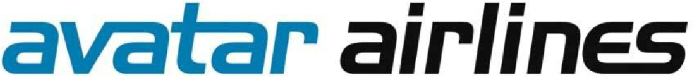

PRIVATE PLACEMENT MEMORANDUM
$300,000,000 of Secured Convertible “Series A” Notes

(Minimum Purchase: $50,000)

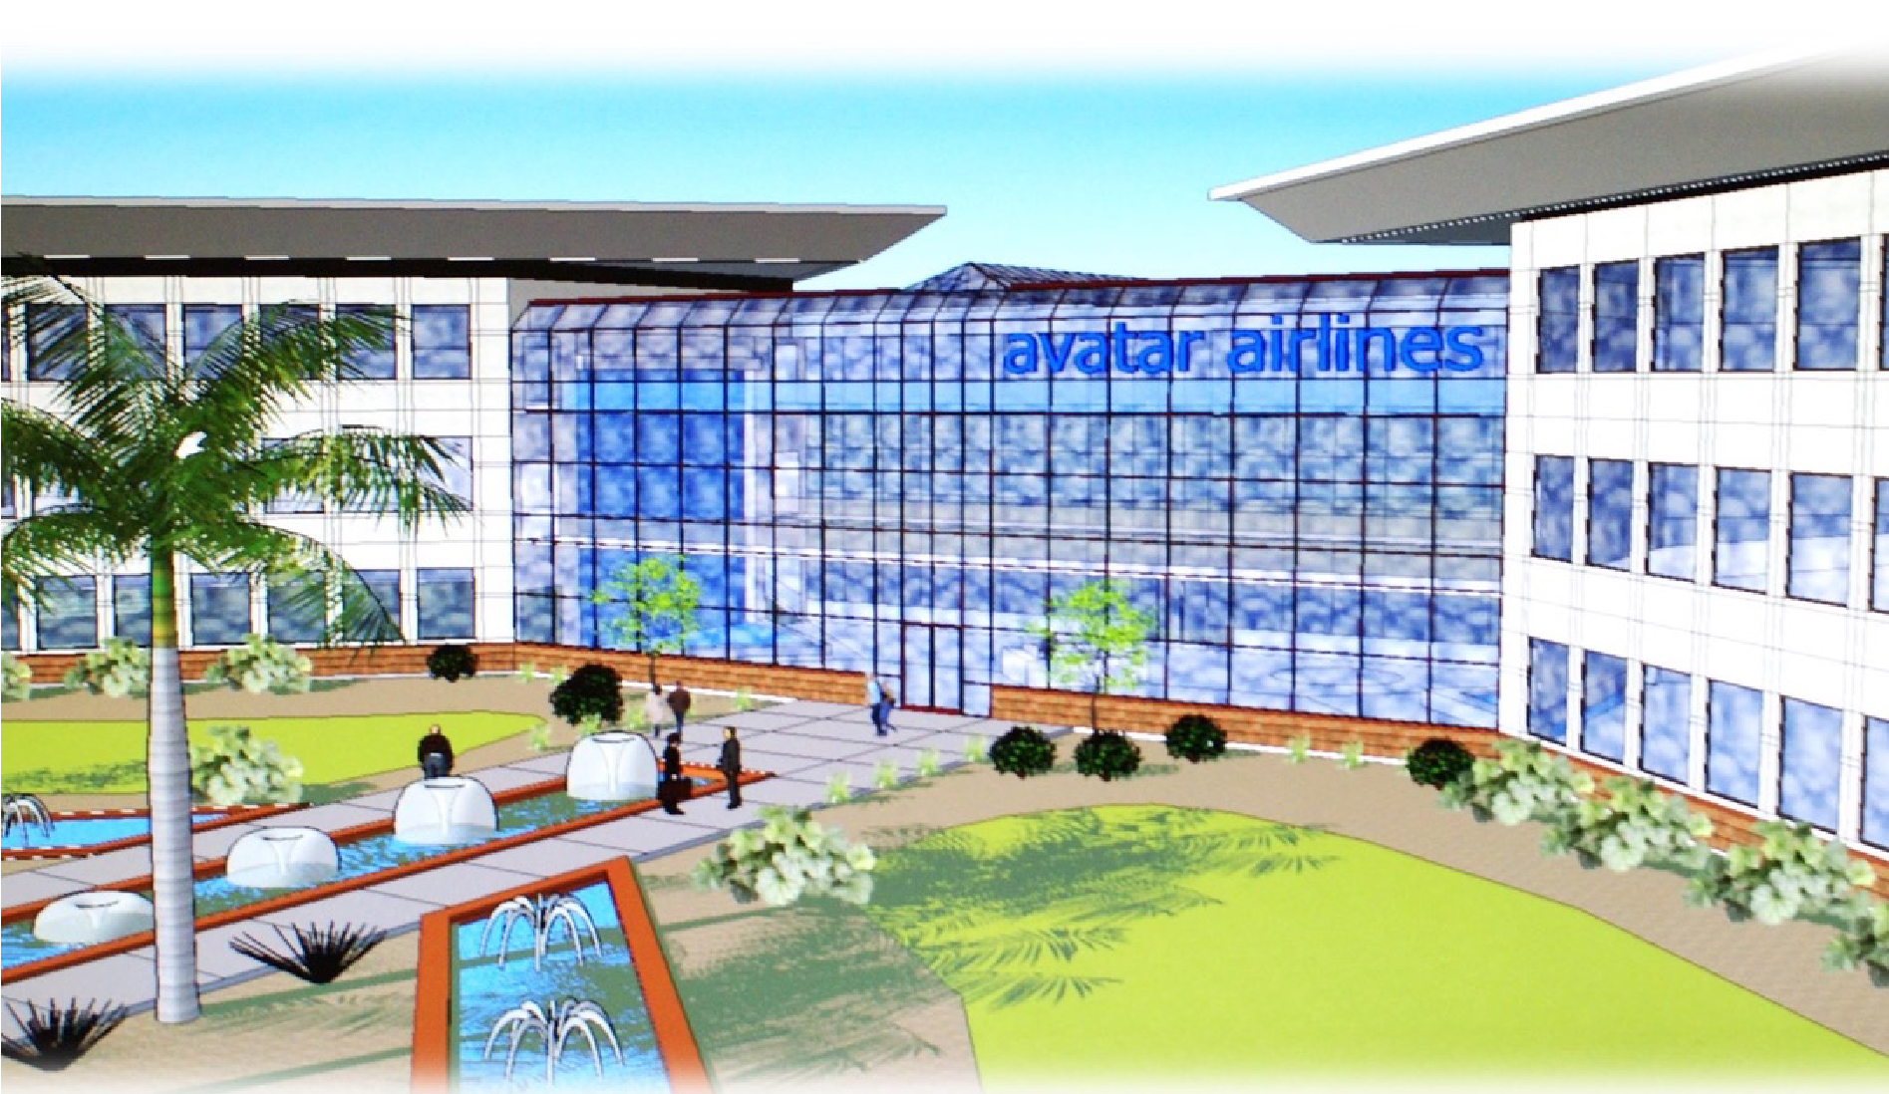

(Conceptual Avatar Airlines 66,000’ Headquarters and Training Center)
Effective June 15, 2024

Avatar Airlines, Inc.
6586 W Atlantic Ave
Suite 2023
Delray Beach, FL 33446 investors@avatarairlines.com

From the Desk of our CEO

WHY AVATAR? “A radical departure.”

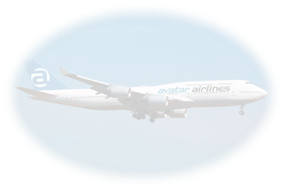
Over the last decade, domestic airlines have continued to downsize. Their belief is that the only way to make a profit is through the process of reduction. Large, wide body passenger aircraft exchanged for smaller, less expensive aircraft. Less passengers to achieve a full payload. But not without consequences. If you’re flying coach, you’ve noticed them. Every time you’ve had to squeeze past another passenger or snack cart. Polite but awkward “battles” for arm rests. Lack of leg room, personal space.

To achieve profitability, their operations still required more of “less.” A successful reduction in consumer expectation. Think about it. They have succeeded. Why else would you pay for luggage that was always included in the cost of your ticket? Why would you pay for seat selection? Leg room? (The list goes on…) You pay because your expectations have been lowered. Eroded, over a period of years. Or … maybe you don’t pay. You “choose” to simply suffer in silence. (That happens to be a very popular option too!) It’s just not a very satisfying option, is it? And yet their plan is as complete as it is “successful.” They have no reason to change it.

But what if I told you there was a better way? Better for passengers, investors and employees. Better for the industry, the economy, and even the environment. “Air travel reimagined.” 581 passengers flying in a comfortable 4-engine wide-body aircraft with one of the safest records, having flown 3 ½ billion passengers– the equivalent of more than half the world’s population! Spacious seats, roomy overhead bins, no additional charge. Bring your luggage, no additional charge. Get up, walk around, you’ve got nearly the length of a football field! It feels like a radical departure, but you’re in familiar territory. You’re on board the Boeing 747!

Did I mention the price of the ticket? Predictable pricing 365 days a year, 30%-50% lower than the ordinary fares of our closest would-be competitors. For example, our regular one-way fares from New York to Miami - $49, from LA to JFK - just $79. By flying only to high-density markets, we believe Avatar will achieve near-to-full load capacity. Avatar’s multiple profit centers are expected to generate significant additional revenue from strategic partners. Purchase your tickets online, and while you’re at it, order up a sumptuous meal. Eat like a King – you’re in good Company! Allow me to introduce your new “Queen of the Skies” - Avatar Airlines.

If you’re a potential investor, We’ve put just as much thought into our financial plan as Company has our business plan. Please review our offering.

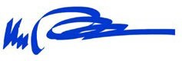
BARRY MICHAELS

Founder and CEO

NOTICE TO OFFEREES

SUMMARY

The following is a summary of the basic terms and conditions of a proposed Secured Convertible “Series A” Promissory Notes financing for Avatar Airlines, Inc (the “Company” or “Avatar” or “Avatar Airlines”). This summary is qualified in its entirety by the discussion contained in this PPM, and the Company’s constitutive documents and agreements identified below. This offering is effective June 15, 2024, and will expire on a “best efforts” basis on December 31, 2024, unless unilaterally extended by Company.

Financing Up to $300,000,000 in aggregate principal amount of Secured Amount Convertible “Series A” Promissory Notes (the “Note(s)” or “Securities”) on a “best efforts” basis.

Closings The Company may close the sale of the Notes in one or more closings with one or more purchasers of the Notes acceptable to the Company (the “Purchaser(s)” or “Investor(s)”).

The Notes will be issued and sold pursuant to a secured
Definitive Agreement convertible note purchase agreement included as Exhibit A to this PPM (Note copy is internal Exhibit 1 to the purchase agreement) (the “Purchase Agreement”).

Maturity Date Principal and unpaid accrued interest on the Notes will be due and payable 48 months from the date of the Note Purchase Agreement (the “Maturity Date”).

Interest Simple interest will accrue on an annual basis at the rate of 8% per annum based on a 365-day year.

If the Company issues equity securities (“Equity Securities”)
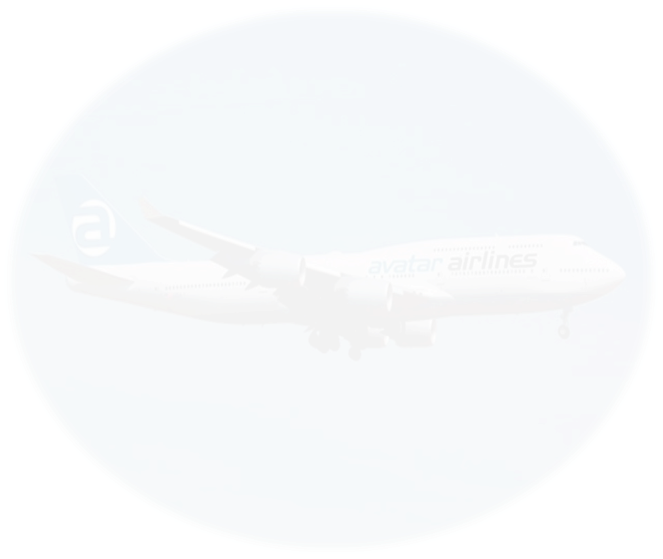
Conversion to Equity in a registered offering under the Securities Act of 1933 then the Notes, and any accrued but unpaid interest thereon, will automatically convert into the equity securities issued pursuant to that offer at a conversion price equal to 75% of
the per share price paid by the purchasers of such equity securities.

Repayment or  Conversion | If the Notes have not been previously converted pursuant to a Qualified Financing, then, effective upon the Maturity Date, the Purchasers will have the right to repayment of any outstanding principal and accredited interest. Alternatively, Purchasers may elect to convert their Notes into Common Stock of the Company at a price announced by the Company at least 30 days prior to the Maturity Date.
Sale of the  Company | If a Public offering under the Securities Act of 1933 has not occurred and the Company elects to consummate a sale of the Company prior to the Maturity Date, then notwithstanding any provision of the Notes to the contrary the Company will give the Investors at least five days prior written notice of the anticipated closing date of such sale of the Company and (ii) the Company will pay the Purchaser of each Note the aggregate amount of principal and interest then outstanding under such Note in full satisfaction of the Company’s obligations under such Note.
Pre-Payment The principal and accrued interest may not be prepaid unless approved in writing by Investor.

Secured Interest The Notes will be secured by the total assets of the Company.

Fees and Each Investor will bear its own fees and expenses incurred in Expenses the transactions contemplated by this term sheet.

Proceeds from this offering will primarily be used for the Use of Funds acquisition of aircraft, acreage to build its headquarters and training facility along with its initial operating expenses.

An investment in the Company is inherently risky and
Risk Factors prospective investors should think critically about the types of risks inherto our industry. Further discussion of the risks Company may face is included under “Risk Factors” below.

This Private Placement Memorandum (the “Memorandum”) relates to the private offer and sale (the “Offer”) of up to $300,000,000 of the Notes of Avatar Airlines, a Nevada corporation. The sale of the Notes of this Offering is being conducted by the Company under Rule 506(c) of Regulation D under the Securities Act of 1933, as amended (the “Securities Act”). You must be an “accredited investor” as defined in Regulation D and meet the other suitability requirements set forth herein under the caption “Investor Suitability Standards” to purchase Notes in this offering.

The Notes offered here are speculative, involve a high degree of risk and should not

be purchased by anyone who cannot afford the loss of their entire investment. You should carefully read this entire Memorandum, including the section captioned “Risk Factors”, before purchasing any Notes. There is no public market for the Notes (or for any other securities of Avatar Airlines, including the common stock into which the Notes may be converted) and no such market is expected to develop in the foreseeable future. Investors should be aware that they may be required to bear the financial risks of this investment for an indefinite period.

THESE NOTES HAVE NOT BEEN REGISTERED UNDER THE SECURITIES ACT OR ANY APPLICABLE STATE SECURITIES LAWS. NEITHER THE SECURITIES EXCHANGE COMMISSION (THE “SEC”) NOR ANY STATE REGULATORY AUTHORITY HAS APPROVED OR DISAPPROVED THESE SECURITIES OR THE
TERMS OF THIS OFFERING; NOR HAS IT BEEN DETERMINED IF THIS MEMORANDUM IS TRUTHFUL OR COMPLETE. IT IS ILLEGAL FOR ANY PERSON TO TELL YOU OTHERWISE.

THE NOTES MAY NOT BE TRANSFERRED IN THE ABSENCE OF AN EFFECTIVE REGISTRATION STATEMENT UNDER THE SECURITIES ACT AND ANY APPLICABLE STATE SECURITIES LAWS OR AN OPINION OF COUNSEL IN FORM AND SUBSTANCE ACCEPTABLE TO THE COMPANY AND ITS COUNSEL THAT SUCH REGISTRATION IS NOT REQUIRED.

Any estimates, projections, and forward-looking statements with respect to future performance set forth in this Memorandum have been provided to assist you in your evaluation, and although they have been prepared based on assumptions and hypotheses that management believes to be reasonable, should not be relied upon as an accurate representation of future results. It is the recipient’s obligation to conduct his/her or its own due diligence. No persons have been authorized to make any representations other than those contained in this Memorandum, and if given or made, such representations should not be considered as authorized.

Sales will only be made to persons who are sophisticated in business and financial matters, who have the knowledge and experience to evaluate the merits and risks of the investment, who have substantial income, who have no need for liquidity with respect to their investment, and who can bear the absence of illiquidity of the securities offered hereby, and who are otherwise “accredited” as such term is defined by SEC Rule 501 of Regulation D.

Statements in this Memorandum are made as of the date hereof unless stated otherwise and neither the delivery of this Memorandum at any time, nor any sale hereunder, shall under any circumstances create an implication that the information contained herein is correct as of any time after this date.

There is currently no public or other market for the Notes, and Company has no obligation and no intention to take any action whatsoever to cause or assist in causing any market to develop for any securities of Avatar Airlines and there can be no assurance that a public or other market will develop. Each prospective investor should proceed only on the assumption that such prospective investor may have to bear the economic risk of an investment in the Notes offered hereby for an indefinite period of time, if the debt is converted to equity under the terms of the offering.

Company reserves the right to reject for any reason any subscription, in whole or in part, or to allot to any prospective investor less than the value of the Notes subscribed for by such prospective investor.

In making an investment decision, investors must rely on their own examination of Avatar Airlines and the terms of this Offering, including the merits and risks involved. Prospective investors should not construe the contents of this Memorandum as investment or legal advice. This Memorandum and the other documents delivered herewith, as well as the nature of an investment in the securities offered hereby, should be reviewed by each prospective investor and such investor’s investment, tax, legal, accounting and other advisors.

The Notes offered by Avatar Airlines are subject to receipt and acceptance of subscriptions, the right to reject any subscription in whole or in part, withdrawal, cancellation, or modification of the offer without notice to investors and certain other conditions.

NOTICE TO PROSPECTIVE PURCHASERS IN ALL STATES

IN MAKING AN INVESTMENT DECISION, INVESTORS MUST RELY ON THEIR OWN EXAMINATION OF THE COMPANY AND THE TERMS OF THE OFFERING, INCLUDING THE MERITS AND RISKS INVOLVED. NO FEDERAL OR STATE SECURITIES COMMISSION OR REGULATORY AUTHORITY HAS RECOMMENDED
THESE SECURITIES. FURTHERMORE, THE FOREGOING AUTHORITIES HAVE NOT CONFIRMED THE ACCURACY OR DETERMINED THE ADEQUACY OF THIS MEMORANDUM. ANY REPRESENTATION TO THE CONTRARY IS A CRIMINAL OFFENSE.

THE NOTES OFFERED HEREBY ARE HIGHLY SPECULATIVE, AND AN INVESTMENT IN THE NOTES INVOLVES A HIGH DEGREE OF RISK. SEE "RISK FACTORS."

NOTICE TO NON-U.S. PERSONS

THE NOTES OFFERED HEREBY HAVE NOT BEEN REGISTERED UNDER THE SECURITIES ACT OR ANY STATE SECURITIES LAWS, AND MAY NOT BE OFFERED, SOLD, PLEDGED, HYPOTHECATED, ASSIGNED, TRANSFERRED OR OTHERWISE DISPOSED OF IN THE UNITED STATES OR TTO U.S. PERSONS EXCEPT PURSUANT TO AN EFFECTIVE REGISTRATION STATEMENT UNDER THE SECURITIES ACT AND SUCH LAWS, OR AN EXEMPTION FROM REGISTRATION UNDER THE SECURITIES ACT AND SUCH LAWS WHICH, IN THE OPINION OF COUNSEL FOR THE PURCHASER, WHICH COUNSEL AND OPINION ARE REASONABLY SATISFACTORY TO COUNSEL FOR THE COMPANY, IS AVAILABLE.

THE DISTRIBUTION OF THIS MEMORANDUM AND THE OFFERING OF THE NOTES MAY BE RESTRICTED BY LAW IN CERTAIN JURISDICTIONS. PEOPLE, INTO WHOSE POSSESSION THIS MEMORANDUM COMES, ARE REQUIRED BY THE COMPANY TO INFORM THEMSELVES ABOUT AND TO OBSERVE ANY SUCH RESTRICTIONS. THIS
MEMORANDUM DOES NOT CONSTITUTE, AND MAY NOT BE USED FOR OR IN CONNECTION WITH, AN OFFER OR SOLICITATION BY ANYONE IN ANY JURISDICTION IN WHICH SUCH OFFERING OR SOLICITATION IS NOT AUTHORIZED OR TO ANY PERSON TO WHOM IT IS UNLAWFUL TO MAKE SUCH OFFER OR SOLICITATION.

NO ACTION HAS BEEN TAKEN BY THE COMPANY THAT WOULD PERMIT AN OFFERING OF THE NOTES OR THE CIRCULATION OR DISTRIBUTION OF THIS MEMORANDUM OR ANY OFFERING MATERIAL IN RELATION TO THE COMPANY OR THE UNITS IN ANY COUNTRY OR JURISDICTION WHERE ACTION FOR THAT PURPOSE IS REQUIRED BY APPLICABLE LAW.

THE COMPANY WILL MAKE AVAILABLE TO ANY PROSPECTIVE INVESTOR, PRIOR TO SALE OF NOTES TO SUCH PERSON, THE OPPORTUNITY TO ASK QUESTIONS OF AND TO RECEIVE ANSWERS FROM REPRESENTATIVES OF THE COMPANY CONCERNING THE COMPANY OR THE TERMS AND CONDITIONS OF THE OFFERING AND TO OBTAIN ANY ADDITIONAL RELEVANT INFORMATION TO THE EXTENT THE COMPANY POSSESSES SUCH INFORMATION OR CAN OBTAIN IT
WITHOUT UNREASONABLE EFFORT OR EXPENSE. INVESTORS AGREE TO ADVISE THE COMPANY IN WRITING IF THEY ARE RELYING UPON ANY SUCH INFORMATION.

THE NOTES OFFERED HEREBY ARE SPECULATIVE AND INVOLVE A HIGH DEGREE OF RISK AND SHOULD NOT BE PURCHASED BY ANYONE WHO CANNOT AFFORD THE LOSS OF HIS ENTIRE INVESTMENT. SEE “RISK FACTORS.”
Inquiries concerning this Memorandum may be directed to Avatar Airlines at the following address:
Avatar Airlines, Inc.
6586 W Atlantic Ave Suite 2023
Delray Beach, FL 33446 investors@avatarairlines.com

Table of Contents
Page

WHY AVATAR? FROM THE DESK OF CEO BARRY MICHAELS ………………………………………… i
NOTICE TO OFFEREES ………………………………………………………………………………………..… ii
SUMMARY ................................................................................................................................................. 01
OFFERING TERMS (see also Ex. “A” copy of Purchase Agreement containing copy of Secured Note) 14
LIQUIDITY, USE OF PROCEEDS AND FINANCING NEEDS ................................................................... 16
FORWARD-LOOKING STATEMENTS ...................................................................................................... 16
INVESTOR SUITABILITY STANDARDS ................................................................................................... 17
ACCREDITED INVESTOR ......................................................................................................................... 18
INVESTMENT PROCEDURE …………………………………………………………………………………… 20
INVESTMENT IN NOTES BY TAX-EXEMPT ENTITIES AND ERISA CONSIDERATIONS ...................... 21
BENCHMARKS ......................................................................................................................................... 22
RISK FACTORS ......................................................................................................................................... 23
Risks Related to the Company ................................................................................................. 24
Risks Related to the Business .................................................................................................. 27
SEC Reg D Rule 506(e) "Felons and Other Bad Actors" Disclosure Statement ...................... 34
MANAGEMENT DISCUSSION AND ANALYSIS ....................................................................................... 38
BUSINESS ................................................................................................................................................. 39
Overview ................................................................................................................................... 40
Corporate Base ......................................................................................................................... 41 Revenue .................................................................................................................................... 41
Competition ............................................................................................................................... 45
FUEL COST ............................................................................................................................................... 46
AIRCRAFT AQUISITION ............................................................................................................................ 48
MAINTENANCE AND REPAIRS ……………………………………………………………………………… ... 48
GOVERNMENT REGULATION ................................................................................................................. 49
FOREIGN OWNERSHIP ............................................................................................................................ 50
KEY MANAGEMENT .................................................................................................................................. 51
SHAREHOLDERS ...................................................................................................................................... 57 DESCRIPTION OF CAPITAL STOCK ....................................................................................................... 57
COMMON STOCK DIVIDEND POLICY…………………………………………………………………….. .... 58
PREFERRED STOCK GENERAL POLICY …………………………………………………………………… . 58
CONTROL SHARE ACQUISITIONS ………………………………………………………………………….. .. 58
LIMITATION OF LIABILITY AN INDEMNIFICATION OF DIRECTORS …………………………………. .... 59
FINANCIAL STATEMENTS (see also Ex. “B” copy of Forward Looking Statement of Income) ............. 59
AVAILABLE INFORMATION ...................................................................................................................... 59

SUMMARY

This summary does not set forth all the information that you should consider before investing in the Notes. You should carefully read this Memorandum and any exhibits attached hereto in their entirety. You should ask questions of the Company and request any additional information you deem necessary prior to deciding to invest in the Company. As used in this Memorandum, “Company,” “Company,” “our,” and “us” refer to Avatar Airlines, Inc., except where the context otherwise requires. Pronouns are used for convenience only. Terms such as “he/him” “she/hers” or “its” all refer to you, the prospective investor, where the context would so require.

An investment in the Notes is speculative and involves a high degree of risk. Prospective investors should retain their own professional advisors to review and evaluate the economic, tax and other consequences of an investment in this private offering and are not to construe the contents of this Memorandum, or any other information furnished, as legal or tax advice.

Company

Avatar Airlines was incorporated under the laws of the State of Nevada on January 27, 2004, under the name Family Airlines, Inc., to engage in any lawful activity. The Company changed its name to Avatar Airlines, Inc. on March 18, 2010. Avatar Airlines plans to operate ultra-low fare, non-stop flights to and from high density markets within the continental U.S. The Company intends to add Hawaii and international flights to its route system at an undetermined future date. Company plans to acquire 14 Boeing 747-400 aircraft during our first year of operation, increasing that number to 30 by the beginning of the fourth year.

Business

Why the 747?

It’s big, it’s safe, it’s cost-effective and it’s comfortable.

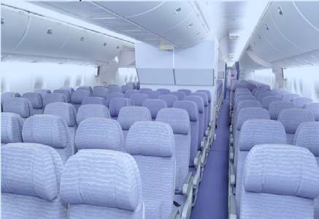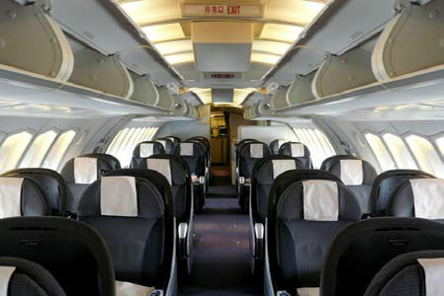
539 – Lower Deck Economy 42- Upper Deck Office Class Each one of Company’s 747 aircraft will be equipped alike, having 539 Economy Class seats on the lower deck and 42 Office Class seats on the upper deck, for a total number of 581 seats.

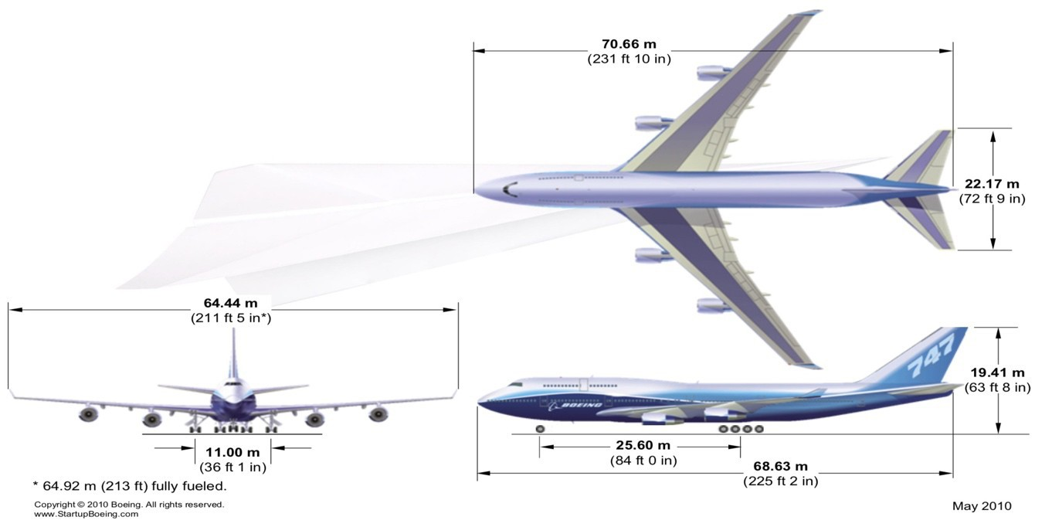
Avatar will offer ultra-low fares for every seat purchased at least 30 days in advance of departure: As an example: Los Angeles to New York, $79; Las Vegas to Los Angeles, $19; and New York to Miami, $49. All of Company’s fares are expected to be substantially lower than other “low fare” airlines. Tickets will be available for purchase up to one year in advance.
Company

believe
s

that

it

can

achieve

profits

and

sustainable

growth

in

today’s

airline

industry

by

having multiple

revenue

and

profit

centers,

rather

than

relying

solely

on

passenger

revenue.

Multiple

profit centers will help keep
Company’s

regular fares

Company believes there is an “untapped” market to sell blocks of seats in advance to tour operators, cruise lines as well as our travel agent affiliates. All of these will be significant factors in driving up seat loads on any given flight.

significantly below Company’s competitors’ regular fares. All revenue centers will be managed by an Executive Director who will have overall responsibility for profit and loss of their center(s) while working together with other staff members as a team to maximize revenue and profitability.

Availability of the 747

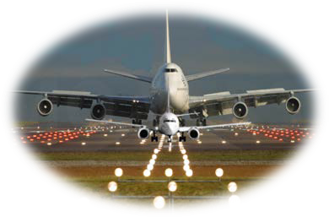
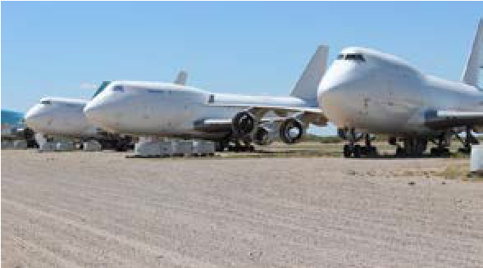
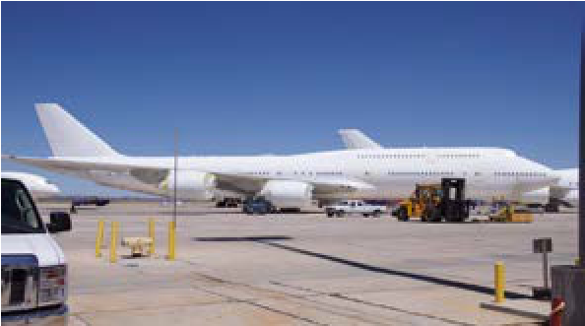
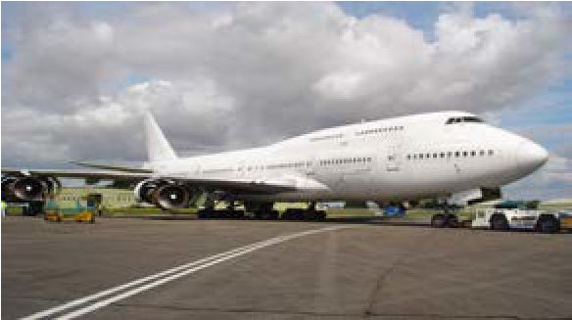
Over the last decade airlines have continued to downsize their aircraft eliminating the large wide body for less expensive smaller narrow body aircraft. Consequentially, there has become an overabundance of 747’s placed in storage. For a short time, they were in demand being converted from passenger aircraft to freighters, from there they were being scrapped for parts and now most are just stored in the desert waiting to fly again or be cut up for scrap. Company believes this has created a buyer’s market with over 60 aircraft currently in desert storage and Company estimates its cost to purchase them including refurbishing will be from $15-25 mm per aircraft. Company intends to purchase them for cash or equity swap.

Stored 747/400’s

The
Boeing 747/400

is

big,

it’s roomy and passengers

just

just

love the idea

of FOUR

engines instead of two, the

size,

comfort and most

of

all

the safety record of this

airplane.

love the fact that they can get up and walk
around, as if they were in a large building. Passengers

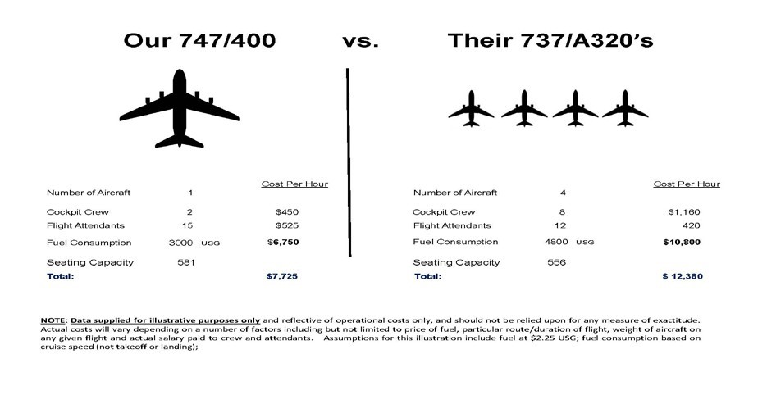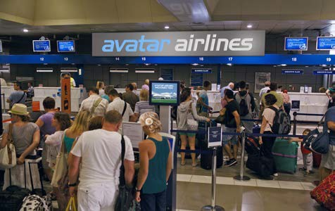
Econom
ies

of scale!

With one plane (the 747) hauling 581 passengers to their destination
Company

hire TWO pilots to fly it. Since many 737s or A320’s hold just about 130
passengers, it would take four

planes

and

8

pilots

to

fly

the

same

load.

That

means

salaries,

benefits,

training

costs,

layovers etc., are
all

reduced, making it a much cheaper method to
get the passengers from Point A to Point

B!

From a
pilot’s

perspective
, if a four
-
engine aircraft has an engine failure, the rules allow
them to proceed to their
destination. A twin
-
engine airplane has no choice but to land at
the nearest
suitable

airport, capable of landing that plane, whether repair services are
available. You are not

allowed

to

pick

and

choose

a

better

place

to

land

that

is

further

away

--

you

must

land

at

the nearest airport that you can safely land. Not so with a three or four
engine

plane!

Passenger Revenue

Company’s initial startup route:

LAX - LAS - JFK - MIA
MIA - JFK - LAS – LAX

Proposed Routes

1st Year 2nd Year 3rd Year

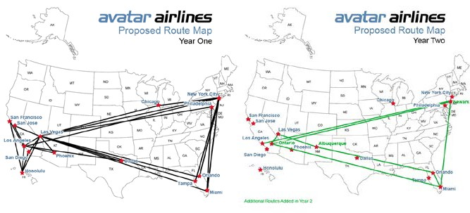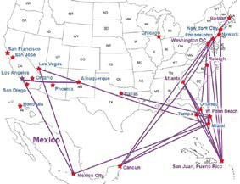

By the beginning of Avatar’s fourth year Company expects to have 28 aircraft crisscrossing the country while at the same time adding a limited number of international routes.

Using Avatar’s JFK to MIA route as an example:

Data provided for the following example is extracted from Avatar’s financial model (available upon request). The Company believes that the assumptions made in the financial model are reasonably conservative (notwithstanding Company’s belief that load factors and revenues will be more favorable than indicated). These estimates allow for a margin of error in either direction, since many of the data points rely on factors that change from day-to-day, and from route-to-route. Accordingly, Company provides this information for illustrative purposes only, and it should not be relied upon for any measure of exactitude.

If seats are purchased at least 30 days prior to the day of flight, the projected one-way fare is $49 plus tax. Three higher-tier fares (Class “B, C & D”) are charged if tickets are purchased within 30 days of the selected travel date.

Company used an 84% load factor (as per NTSB), and projects an average ticket price of $64¹ (plus tax) based on the following:

 |  | Allocation | Sold | Each
Office Class |  |  | 35 | $179
Family Class A |  | 85% | 385 | $49
Family Class B |  | 5% | 23 | $69
Family Class C |  | 5% | 23 | $89
Family Class D |  | 5% | 22 | $119

_{Total 488}

Average ticket price $64¹

(For simplicity, calculations are rounded to the nearest dollar:)

Passenger seat revenue only (488 seats @ $64) amounts to $31,407.¹
Direct flight costs (excluding depreciation and cargo ²) include but are not limited to an average airport fee (including standard luggage handling) across all potential airports (not specific to JFK or MIA) of $5,856; it also includes an average fuel cost of $12,301 ³ and various other direct flight costs of $11,311, amounting to an approximate total of $29,468. Please refer to our financial model for additional details of included costs (model available upon request).

The result is a net flight income of $1,938 (JFK-MIA)
(Not including ancillary revenue, ancillary expenses, or depreciation)

Although Avatar is utilizing an 84% load factor, Company believes that load factors up to 100% are achievable. Budget air travel is a fare-driven market no longer governed by “brand loyalty.” Please refer to Company’s financial model for additional details of included costs (model available upon request).
Given that Avatar’s regular fares will be substantially lower than its closest competitors’ fares, most budget-conscious travelers will likely opt for a seat on Avatar as the more attractive alternative. Tickets may be purchased up to one year in advance. Avatar believes there is an “untapped” market to sell ticket-blocks as part of travel packages with tour operators, popular cruise lines and travel agencies. All of these will be significant factors in driving up seat loads on any given Avatar flight.

- $64 weighted average is rounded from $64.358. $64.358 * 488 = $31,406.70 rounded to $31,407
- Cargo is a separate profit center that will generate additional revenue not included in “Passenger Seat Revenue”
- Fuel is estimated at 5 USG per mile, at a cost of $2.25 per USG (per International Air Transport Assoc (IATA)), for $11.25 per mile. Estimated mileage for JFK to MIA is 1,093.45 @ $11.25 per mile amounts to $12,301.31

Ancillary Revenue

Cargo

Another important factor is not only will Avatar be capable of hauling 581 passengers on each flight, but at the same time it will be capable of carrying an estimated 60,000 lbs. of cargo. Because of this, Avatar’s cost per seat mile is projected to be the lowest in the industry. The cargo market among domestic passenger airlines in the United States has become scarce, primarily because of downsizing of aircraft and increased passenger loads.

Avatar Airlines plans to fly the wide-body Boeing 747-400 aircraft exclusively with its capacity to transport 581 passengers along with a full load of freight. In many cases an aircraft with a full load of freight would not need to carry a single passenger to turn a profit.

Foreign airlines with wide-body aircraft continue to fly into this country but are forbidden by law to go beyond their port of entry. So, they must dismantle their pallets and containers and put them on trucks to their final destination. This would open the door to lucrative contracts through code sharing between these airlines and Avatar Airlines. In many cases Avatar can compete with trucking since its costs of transporting freight is projected to be covered by its passenger revenue.

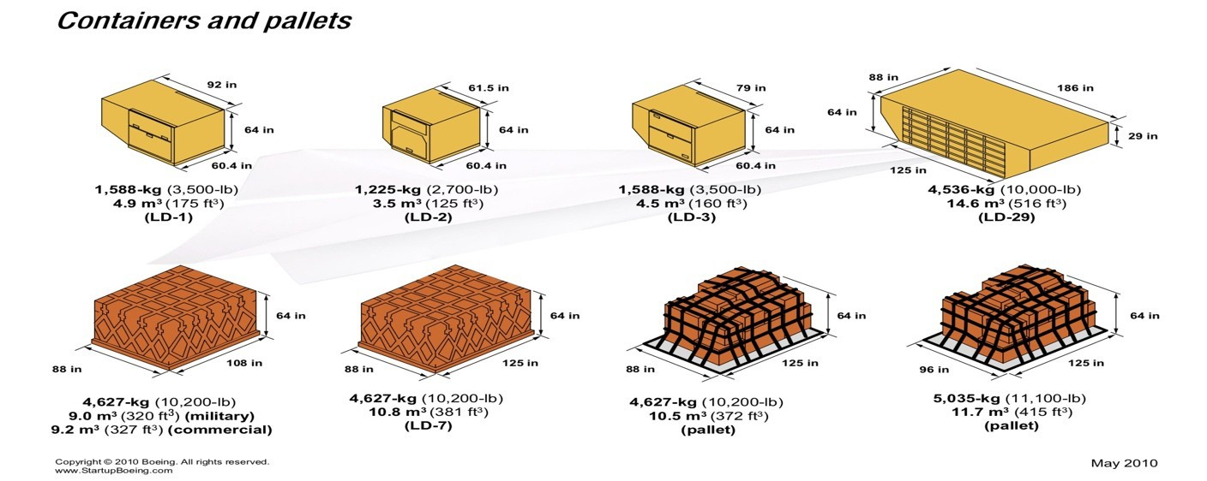

Food & Beverage

Avatar believes offering unique types of food and beverage is another way of building customer loyalty through one’s own pallet. Company understands food and beverage sales represents a small revenue source, but Company believes the experience will distinguish Avatar from its competition, literally gaining notoriety by “word of mouth.”

Imagine a gastronomical experience unavailable anywhere else. Whether it’s a Chef of the Month delight, a snack or just one of our creations, you’re apt to find it available on an Avatar Airlines flight. Company also expects to offer several different ethnic varieties and a full kosher menu. Availability of food items is exclusive to online pre-purchasing at time of ticketing.

(for illustration only)

Marketing & Free Flights



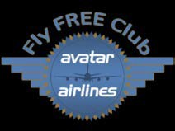
Avatar’s FOCUS Program allows a consumer to “earn a free flight” whether she is already on one of our flights, or just sitting at home. By partnering with various marketing and manufacturing firms, participating members who meet certain demographic criteria may be selected to give their opinion on a wide array of questions pertaining to a subject matter. Upon satisfactory completion, the participant will be awarded a fully transferable certificate good for a free flight to any Avatar Airlines destination valid for a period of two years. The Company earns a fee for each participant, and Avatar expects the revenue that Company receives for it to be worth significantly more than the price of the seat Avatar will “give away.” It is a “win” for Avatar, partners and passengers alike.

Avatar’s Fly “Free” Club

By joining Avatar’s Fly “Free” Club and paying a one-time registration fee of $49, plus $249 a year, a passenger is set to fly “Free” on any available Avatar flight (just paying the taxes). Think of it as flying stand-by without a charge. Passengers just check the Avatar website 72 hours prior to flight time and if there’s an open seat the passenger will be able to place her name on that seat. All available seats will be awarded on a first come first served basis to active Club members.

Branding & Media for Sales

Branding inside of public transportation is not new. Advertisements have been on buses, subways, and taxicabs for years, but not on U.S. airlines. Avatar will make almost anything and everything available for purchase to its strategic partners for a multitude of branding possibilities, both inside and outside the aircraft. Whether it’s an entire fuselage wrap, tray tables, overhead bins or even a video monitor on a bulkhead.

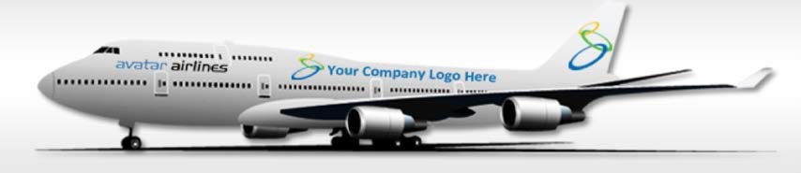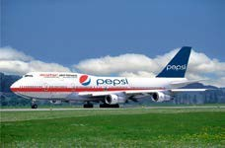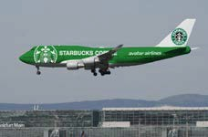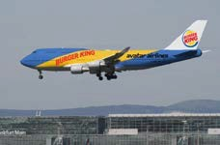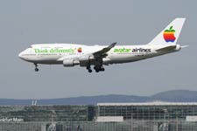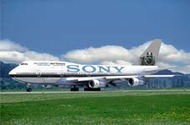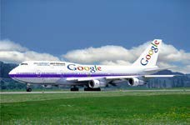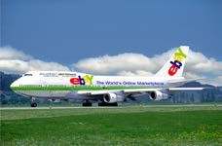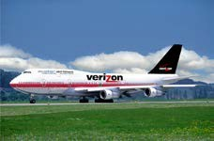

(
All product names, logos, and brands are for illustrative purposes only and remain property of

their respective owners)

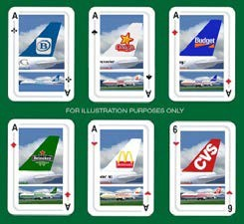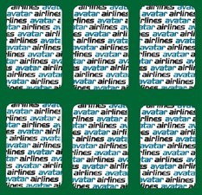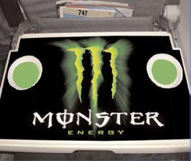

Avatar Vacations

Avatar expects to work with travel agents, but not in the old traditional way. Once registered as an affiliate, agencies will be able to log in and have access to purchase seats on any flight and will not have to put the passenger’s name in until check-in time. In addition, they will have access to purchase tour packages at wholesale rates and charge their client(s) whatever they feel is appropriate.

All affiliates will be listed as a preferred provider on our website with a hot link to their website and included in a fully searchable database by name and area. Our affiliates will receive periodic offers and promotions not offered to the general public. The number of agency affiliates will be limited.

Avatar will contract with major tour operators who will provide complete packages including hotel and rent-a-cars, as well as other local area promotions at wholesale prices. The general public will not have access to this portion of our website.

Insurance


All of Avatar’s passenger tickets are non-refundable and non-exchangeable, however, for a small fee a ticket becomes fully exchangeable. Since Avatar expects to self-insure, these fees represent a pure profit by allowing Avatar to resell that seat.

Looking Forward

Corporate Headquarters

As part of its long-term construction plan, Avatar plans to begin by building its corporate headquarters consisting of a 66,000 ft. building with three floors and two separate wings, one for administration, the other for training, attached in the center by a central lobby. The final design will encompass Avatar’s employee-friendly culture throughout its facilities.


Avatar Headquarters & Training Center (illustrative purposes only)

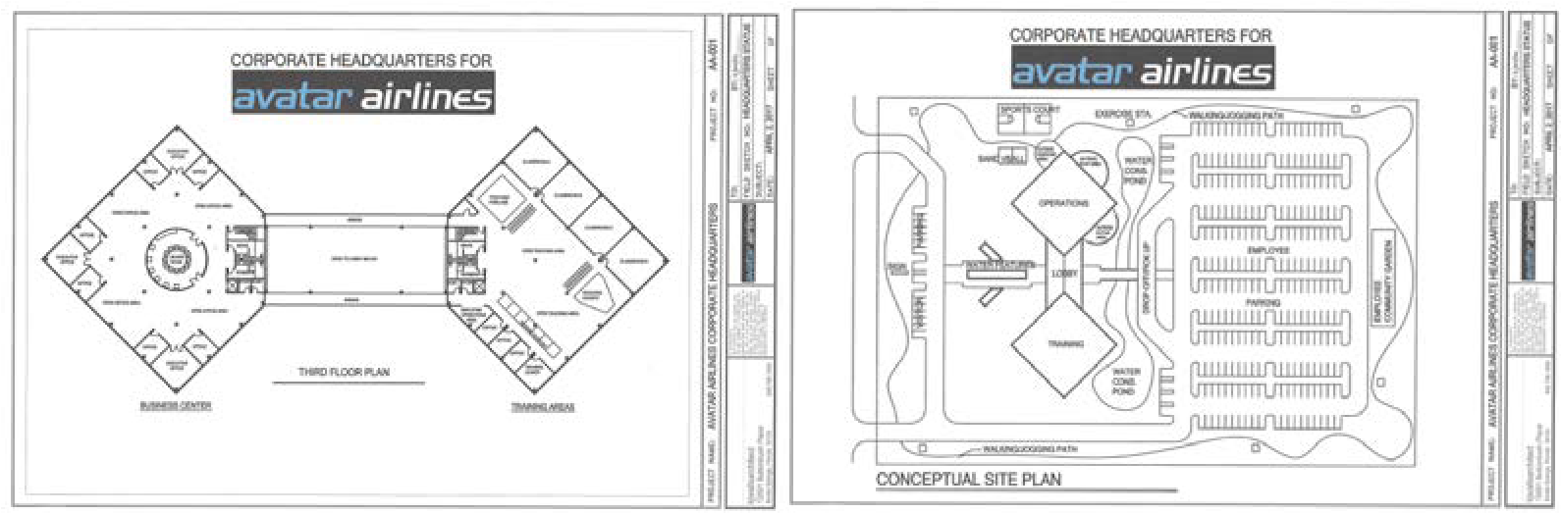
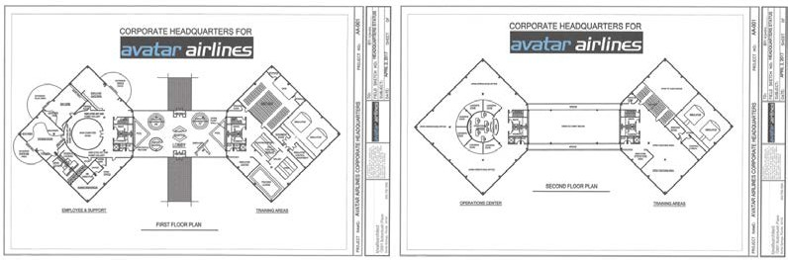
Company expects the Avatar Training Center to be complete with multiple 747 simulators along with 747 aircraft cabin trainers used for flight attendant training. Additional revenue is expected from training contracts associated with other airlines, especially international ones.

Artist rendition
-

for illustration only
Estimated construction cost for
the building shell (structure
-

footings, steel, etc., exterior walls
including

fenestrations,

and

roofing)

and

the

interior

finishes

including

walls,

drywall,

flooring,

ceilings,

etc.

Assuming

it

is

not

real

high
-
end finish materials (what
Company

call "lawyer office finishes" and in these numbers not including such items as IT systems, training
equipment (simulators, etc.), the following should be a good start
-

somewhat

conservative but not

extravagant.

Building Shell
-

66
,000 sf at $100/sf = $6,600,000, Interior Fit Up
-

,000 sf at $60/sf = $3,960,000 Total Cost: $
66
10,560,000

Advanced

employee

corporate

culture

is

an

integral

part

of

what

Company

expects

will

set

Avatar

Airlines apart from others. Built
-
in benefits such as a childcare center, health spa
and cafeteria are just a few of the benefits
Company

envision
s

awaiting members of the
Avatar

team.

Training Center

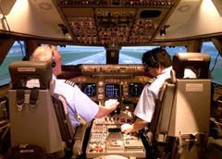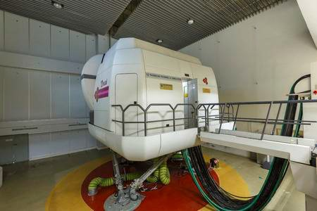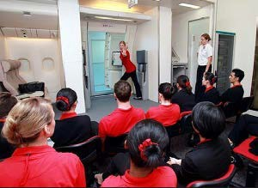

(For illustrative purposes only)

The Avatar 300-Room Hotel

Company plans to build a 300-room hotel on the same property as its headquarters. An ideal place for visitors to Avatar’s training facility as well as for general tourism. Although the hotel will be owned by Avatar, Company expects it to be maintained and managed by one of Avatar’s hospitality partners.

Passenger Terminals

Turnaround time is an important issue when it comes to efficiency since an aircraft on the ground does not generate revenue. Most aircraft load and unload from a single jetway, but some airports have gates with dual jetways for large body aircraft.

In order to increase aircraft utilization and decrease passenger loading time and with the cooperation of the airports served, Avatar intends to build its own passenger terminals. These will be designed and constructed to provide efficiency by using multiple jetways (up to four) necessary to load and unload each aircraft by providing extra-large gates accommodating as many as 1,200 awaiting passengers.

Artist rendition - for illustration only

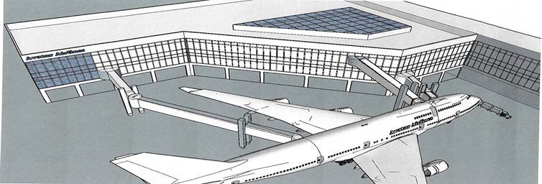
Avatar’s terminals are expected to provide additional revenue with thousands of square feet of restaurant and retail spaces available for lease. Concessions would be located on both sides of security. The plan includes some concessions on the landside of the terminal to provide for “meet and greet” and some for deplaning passengers. Most of the concessions are planned for the airside of security for enplaning passengers. The average sales in the 1980’s was about $3 per square foot. Today, it is closer to $9 to $10 per square foot for departing passengers. Based on this rate and a concessions area of 20,000 sq. ft., our sales would be about $200,000 monthly.

FAA Part 145 Repair Station
Avatar’s future includes building its own airport hangar large enough to accommodate two 747’s side by side. Recognized as one of its largest expenses, aircraft maintenance will eventually be provided by Avatar’s own staff as an FAA 145 repair station. The location for this facility would be based primarily on job creation incentives provided by the airport and the surrounding municipalities.

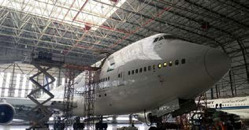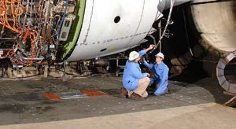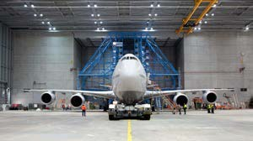
(illustrative purposes only)
The 200,000 square-foot facility would have a 300’ clear span and 40’ sidewalls, culminating in a center height of 100’.

Initial Public Offering

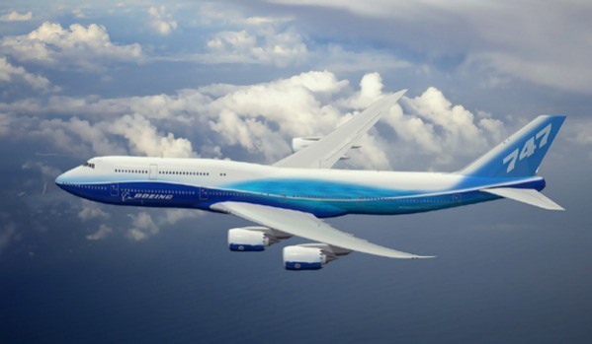
Company’s plan is to go public within 3–5 years of flight operations to raise capital to purchase 30 Boeing 747/8 aircraft. Company expects that by such time, the Company will have significant brand recognition, will have greatly improved the perception of the low fare air travel experience, and will have a positive track record of revenue and earnings to justify an IPO. Note, however, that the Company cannot guarantee these events will happen or that they will in fact result in a successful IPO.

The 747/8 and Avatar’s Future Fleet

Company believes its future lies with the Boeing 747/8 passenger aircraft or its equivalent. This aircraft will allow Avatar to carry 50 more passengers on the upper deck and an additional amount of freight all at significant fuel savings.

Avatar plans include the initial purchase of 30 of these in conjunction with the release of its Initial Public Offering (IPO) within 3–5 years at an estimated value exceeding $10 billion dollars.
The 747-8 is the largest commercial aircraft manufactured and is more than 10 percent lighter per seat, consuming 11 percent less fuel per passenger than the A380, translating into a trip-cost reduction of 21 percent and a seat-mile cost reduction of over 6 percent. This aircraft will represent a tremendous savings in fuel cost over the 747/400, which is Avatar Airlines number one cost.
The 747-8 feature a fuselage stretch of 18.3 ft (5.6 m) over the 747-400, bringing the total length to 250 ft 2 in (76.25 m) and is currently the world's longest passenger aircraft.
Boeing 747-800

TERMS OF THE OFFERING

The following is a summary of the basic terms and conditions of Avatar’s proposed Secured Convertible “Series A” Notes financing. This summary is qualified in its entirety by the discussion contained in this PPM, and the Company’s constitutive documents and agreements identified

below.

Issuer

Investors

Securities Offered
Maturity Date

Interest

Conversion to Equity

Repayment or Conversion

Sale of the Company
Pre-Payment
Avatar Airlines, Inc., a Nevada corporation.
Accredited investors and qualified institutional buyers in the United States and persons who are not U.S. persons as defined in Regulation S under the Securities Act. The Notes are being sold under Regulation D Rule 506(c) via this Memorandum, exempt from registration under the Securities Act.
$300,000,000 in aggregate principal amount of Secured Convertible “Series A” Notes with a minimum purchase price of $50,000. The Notes will be issued and sold pursuant to a Secured Convertible Note Purchase Agreement (the “Purchase Agreement”), a true copy annexed to this PPM as Exhibit A and a Series “A” Secured Promissory Note (the “Note(s)” or “Securities”), true copy contained within the Purchase Agreement as Ex. 1.
Principal and unpaid accrued interest on the Notes will be due and payable 48 months from the date of the Note Purchase Agreement (the “Maturity Date”).
Simple interest will accrue on an annual basis at the rate of 8% per annum based on a 365-day year.
If the Company issues equity securities (“Equity Securities”) in a registered offering under the Securities Act of 1933 then the Notes, and any accrued but unpaid interest thereon, will automatically convert into the equity securities issued pursuant to that offer at a conversion price equal to 75% of the per share price paid by the purchasers of such equity securities.
If the Notes have not been previously converted pursuant to a Qualified Financing, then, effective upon the Maturity Date, the Purchasers will have the right to repayment of any outstanding principal and accredited interest. Alternatively, Purchasers may elect to convert their Notes into Common Stock of the Company at a price announced by the Company at least 30 days prior to the Maturity Date.
If a Public offering under the Securities Act of 1933 has not occurred and the Company elects to consummate a sale of the Company prior to the Maturity Date, then notwithstanding any provision of the Notes to the contrary the Company will give the Investors at least five days prior written notice of the anticipated closing date of such sale of the Company and (ii) the Company will pay the Purchaser of each Note the aggregate amount of principal and interest then outstanding under such Note in full satisfaction of the Company’s obligations under such Note. The principal and accrued interest may not be prepaid unless approved

in writing by the Investor holding the Note(s).

Secured Interest The Notes will be secured by the total assets of the Company.

Fees and Expenses Each Investor will bear its own fees and expenses incurred in the transactions contemplated by this term sheet.

Use of Funds Proceeds from this offering will be used to cover all startup costs and obtain both an FAA Aircraft Operating Certificate (AOC) and DOT Certificates of Public Convenience and Necessity to operate as an
Interstate passenger and cargo air carrier. To complete these tasks the Company will purchase its first 747-400 aircraft to complete the FAA air carrier operating tests. In addition, the Company intends to locate and build a corporate headquarters along with its adjacent training facility.

Upon the completion of the sale of its Secured Convertible Notes the Company intends to offer its first round of Series A Preferred Shares in a private equity offering. The funds from this offering will be used to purchase an additional 13 aircraft.

Prior to the issuance the holders of Series A Convertible Notes will be given the option of converting their notes into Convertible Preferred Shares at the same discount rate or to hold their notes until maturity. This will hold true for any future equity offering that may occur prior the note maturity date.

Broker Placement As of the date of this Memorandum, Avatar Airlines has executed a Fees and Expenses sales placement with broker-dealer SeriesOne Securities LLC on 6month renewable terms of 4.0% of the aggregate of capital commitments each such fee to be deducted from investment at each closing.

REST OF PAGE INTENTIONALLY BLANK

.

LIQUIDITY, USE OF PROCEEDS AND FINANCING NEEDS

The net proceeds to be received by Avatar Airlines from the sale of all the Notes offered hereby are estimated at $28,800,000 assuming that all such Notes are sold through brokers and/or dealers at a commission rate of 4% (i.e., $1,200,000). Avatar Airlines currently has no other prospective source of capital other than from the sale of the Notes in this Offering.

Avatar Airlines anticipates that a portion of the net proceeds of this Offering will be used for start-up expenses prior to the commencement of revenue operations, including the following general categories of expenditures: (i) pre-operating expenses, including salaries and related costs, aircraft crew and ground support training, and advertising and marketing costs; (ii) insurance; (iii) capital expenditures for property and equipment; (iv) security deposits for office and airport facilities; (v) refurbishment and acquisition of Boeing 747 aircraft; and (vi) working capital and general corporate purposes.

To the extent there are any remaining proceeds of this offering after disbursements are made for the above expenses and costs, Avatar Airlines will invest those remaining proceeds in U.S. Treasury Bills, or any other secured, interest-bearing, low risk, short term investment(s). Avatar Airlines has not commenced revenue operations, and there exists the possibility of unforeseen events and changes in business conditions. The foregoing is an estimate of the allocation of the net proceeds of this Offering.

FORWARD - LOOKING STATEMENTS

This Memorandum contains forward-looking statements within the meaning of Section 27A of the Securities Act. These statements include the plans and objectives of management for future operations, including plans and objectives relating to Avatar Airlines’ future growth. The forward-looking statements included herein are based on current expectations that involve numerous risks and uncertainties identified in this Memorandum. Assumptions relating to the foregoing involve judgments with respect to, among other things, future economic, competitive and market conditions and future business decisions, all of which are difficult or impossible to predict accurately and many of which are beyond control. Words or phrases such as “anticipate,” “believe,” “continue,” “ongoing,” “estimate,” “expect,” “intend,” “may,” “plan,” “potential,” “predict,” “project” or similar words or phrases, or the negatives of those words or phrases, may identify forwardlooking statements, but the absence of these words does not necessarily mean that a statement is not forward-looking. Although the management of Avatar Airlines believes the assumptions underlying the forward-looking statements are reasonable, any of the assumptions could be inaccurate and, therefore, there can be no assurance that the forward-looking statements included in this Memorandum will prove to be accurate. The Company’s actual results could differ materially from those anticipated in forward-looking statements for many reasons, including the factors described in the section entitled “Risk Factors.” Considering the significant uncertainties inherent in the forward-looking statements included herein, which speak only as of the date of this Memorandum, the inclusion of such information should not be regarded as a representation by the Company, its management, or any other person that its objectives and projections will be achieved.

Unless required by law, the Company and its management undertake no obligation to revise any forward-looking statement to reflect circumstances or events after the date of this Memorandum or to reflect the occurrence of unanticipated events.

INVESTOR SUITABILITY STANDARDS

The Notes are suitable for those investors whose business and investment experience, either alone or together with an experienced advisor, makes them capable of evaluating the merits and risks of their prospective investment and who can afford the loss of their entire investment in the Notes and have no need for liquidity in their investment. See “Risk Factors.”

The Notes are being offered and will be issued in reliance on certain exemptions from registration and qualification, which are available under federal and state securities laws for non-public offerings of securities. The Company intends to rely upon the exemption for non-public offerings provided by Rule 506(c) of Regulation D under the Securities Act, as well as appropriate exemptions under state securities laws and regulations.

Each Investor purchasing Notes in this Offering shall, by signing and delivering the Purchase Agreement which the Company will rely in claiming an exemption from the registration requirements of the Securities Act, make material representations including, without limitation, the following:

- The Investor understands that it must bear the economic risk of the investment for an indefinite period because no public market will exist for the Note(s) and none is expected to develop.

- The Investor understands that the Notes will not be transferable under federal and state securities laws except under limited circumstances and in reliance upon an opinion of counsel satisfactory to the Company that the proposed transfer is exempt from the registration requirements of the Securities Act.

- The Investor is acquiring the Notes for the Investor’s own account for investment and is not acquiring any Notes with a view to or for sale in connection with any distribution thereof within the meaning of the Securities Act.

- The Investor has received, read carefully and is familiar with this Memorandum, and the Company has, during the course of this offering and
prior to the sale of the Notes to the Investor, afforded the Investor and its representative, if any, the opportunity to ask questions and receive answers from management concerning the terms and conditions of this offering and to obtain any additional information necessary to verify the accuracy of the information contained in this Memorandum.

- The Investor understands the speculative nature of its investment in the Notes, has no need for liquidity with respect thereto, and can sustain a complete loss of the Investor’s investment.

- The Investor is an “accredited investor” as defined in Rule 501(a) of Regulation D.

- The Investor has such knowledge and experience in finance, securities, investments, and other business matters to be able to protect the Investor’s interests in connection with an investment in the Notes.

- The Investor is not a member of FINRA or other self-regulatory agency that would require prior approval of a purchase of the Notes.

- Additional or more stringent requirements may apply to Investors residing in certain states.

ACCREDITED INVESTOR

An accredited investor is defined in Rule 501(a) of Regulation D promulgated, and as amended from time to time, under the Securities Act to include the following:

- Any bank as defined in Section 3(a)(2) of the Securities Act whether acting in its individual or fiduciary capacity; insurance Company as defined in Section 2(13) of the Securities Act; investment Company registered under the Investment Company Act of 1940 or a business development Company as defined in Section 2(a)(48) of the Securities Act; Small Business Investment Company licensed by the U.S. Small Business Administration under Section 301(c) or (d) of the Small Business Investment Act of 1958; employee benefit plan within the meaning of Title I of the Employee Retirement Income Security Act of 1974, if the investment decision is made by a plan fiduciary, as defined in Section 3(21) of such Act, which is either a bank, insurance Company, or registered investment advisor, or if the employee benefit plan has total assets in excess of $5,000,000;

- Any private business development Company as defined in Section 202(a)(22) of the Investment Advisors Act of 1940;

- Any organization described in Section 501(c)(3) of the Internal Revenue Code, or any corporation, Massachusetts or similar Business trust, or Company, not formed for the specific purpose of acquiring the securities offered, with total assets in excess of $5,000,000;

- Any director or executive officer of the Company;

- Any natural person whose individual net worth, or joint net worth with that person’s spouse, in either case, at the time of his or her purchase exceeds $1,000,000, excluding the value of the primary residence of such person;

- Any natural person who had an individual income in excess of $200,000 in each of the two most recent years or joint income with that person’s spouse in excess of
$300,000 in each of those years and has a reasonable expectation of reaching the same income level in the current year;

- Any trust, with total assets in excess of $5,000,000 not formed for the specific purpose of acquiring the securities offered, whose purpose is directed by a sophisticated person as described in Section 230.506(b)(2)(ii) of 17 CFR §230; or

- Any entity in which all the equity owners are accredited investors.

A PROSPECTIVE INVESTOR IN THE NOTES MUST RELY ON THE INVESTOR’S PROFESSIONAL ADVISORS TO DETERMINE WHETHER THE NOTES ARE A SUITABLE INVESTMENT.

THIS MEMORANDUM SHALL NOT CONSTITUTE AN OFFER TO SELL TO, OR A SOLICITATION OF AN OFFER TO BUY FROM, ANY PERSON WHO DOES NOT MEET THE SUITABILITY STANDARDS SET FORTH ABOVE AND IN THE SUBSCRIPTION AGREEMENT.

Restriction imposed by the USA PATRIOT Act and Related Acts

The Notes may not be offered, sold, transferred, or delivered, directly or indirectly, to any Unacceptable Investor. The term “Unacceptable Investor” means and includes the following:

- A person or entity, who is a designated national, specially designated national, specifically designated terrorist, specially designated global terrorist organization, or blocked person within the definitions set forth in the Foreign Assets Control Regulations of the U.S. Treasury Department;

- A person acting on behalf of or any entity owned or controlled by, any government against whom the U.S. maintains economic sanctions or embargoes under the Regulations of the U.S. Treasury Department;

- A person or entity who is within the scope of executive Order 13224-Blocking
Property and Prohibiting Transactions with Persons who Commit, Threaten to Commit, or Support Terrorism, effective September 24, 2001; or

- A person or entity subject to additional restrictions imposed by the following statues or regulations and executive orders issued there under: the Trading with the Enemy Act, the Iraq Sanctions Act, the National Emergencies Act, the Antiterrorism and Effective Death Penalty Act of 1996, the International Emergency Economic Powers Act, the United Nations Participation Act, the International Security and Development Cooperation Act, the Nuclear Proliferation Prevention Act of 1994, the Foreign Narcotics Kingpin Designation Act, the Iran and Libya Sanctions Act of 1996, the Cuban Democracy Act, the Cuban Liberty and Democratic Solidarity Act and the Foreign Operation, Export Financing and Related Programs Appropriations Act or any other law of similar import as to any non-U.S. country, as each such act or law has been or may be amended, adjusted, modified or reviewed from time to time.

INVESTMENT PROCEDURE

- To purchase a Note, each prospective Purchaser will be required to furnish documentary proof to Company or its designated agents that Purchaser is an “accredited investor,” as such term is defined in Rule 501(a) of Regulation D of the Securities Act. Purchaser shall also be required to execute and deliver the Purchase Agreement to Company.

- Once Purchaser is verified as an accredited investor, and otherwise approved in Company’s sole discretion, and the Parties other agree to close on the Note, closing shall be scheduled whereupon Purchaser shall tender payment for the loan amount contemporaneously with Company’s execution of the Note, and the Parties shall execute any other pertinent documentation necessary to complete the closing transaction on the Note. Closing on the Note shall take place at the following corporate headquarters for Company, or at such other place or manner as agreeable between Company and Purchaser:

Avatar Airlines, Inc. c/o Law Offices of Michael E. Zapin

301 W Atlantic Ave, Suite 0-5
Delray Beach, FL 33444 investors@avatarairlines.com

3. No Escrow Agent. Funds tendered by Purchasers at closing will be paid to Company’s operating account and will be immediately available to Company.

INVESTMENT IN NOTES BY TAX-EXEMPT ENTITIES AND ERISA CONSIDERATIONS

In considering an investment in the Notes of a portion of the assets of a Benefit Plan, as defined in the Employee Retirement Income Security Act (“ERISA”), the fiduciary of the Benefit Plan subject to ERISA should consider the provisions of the Code, ERISA and other applicable law. In this regard, IRAs, which are not sponsored or endorsed by an employer or by an employee organization and Keogh Plans (which are plans under which only partners or a sole proprietor are participants) generally are not subject to the provisions of ERISA; however, fiduciaries of such accounts should review carefully the matters discussed below.

In general, before investing in the Notes, the fiduciaries of an ERISA Benefit Plan should consider whether:

- an investment in the Notes is consistent with their fiduciary obligations under ERISA;

- an investment in the Notes is a prudent investment for the ERISA Benefit Plan in accordance with Section 404(a)(1)(B) of ERISA;

- an investment in the Notes complies with the requirements under Section 404(a)(1)(C) of ERISA that ERISA Benefit Plan investments be diversified so as to minimize the risk of large losses;

- an investment in the Notes is made in accordance with the documents and instruments governing the ERISA Benefit Plan, including the Plan‘s investment policy, and in accordance with the terms of any trust or other fund maintained in connection with the Plan;

- an investment in the Notes will constitute a prohibited transaction under Section 406 of ERISA or Section 4975 of the Code; and

- whether the investment in the Notes will result in unrelated business taxable income.

Minimum Distribution Requirements

Potential investors who intend to purchase Notes in their IRAs, and any trustee of an IRA or other fiduciary of a Benefit Plan considering an investment in Notes, should take into consideration the limited liquidity of an investment in the Notes as it relates to applicable minimum distribution requirements under the Code for the IRA or other Benefit Plan. If the Notes are still held in the IRA or Benefit Plan at such time as mandatory distributions are required to commence to the IRA beneficiary or plan participant, Section 401(a)(9) of the Code will likely require that a distribution in kind of the Notes be made to the IRA beneficiary or plan participant. Any such distribution in kind of Notes must be included in the taxable income of the IRA beneficiary or plan participant for the year in which the Notes are received at the then current fair market value of the Notes without any corresponding cash distributions with which to pay the income tax liability arising out of any such distribution. The fair market value of any such distribution in kind will be only an estimated value per Share and there can be no assurance that such estimated value could actually be realized by an investor because (1) estimates do not necessarily indicate the price at which Notes could be sold and (2) no public market for Notes exists or is likely to develop.

BENCHMARKS

DOT APPLICATION: Avatar filed a certificate of Public Convenience and Necessity with the Department of Transportation (“DOT”) and will need to comply with various requirements pertaining to compliance disposition, managerial competence, and economic fitness.

FAR PART 121 CERTIFICATE: Avatar will need to a file letter of intent with the Federal Aviation Administration (“FAA”) for issuance of a FAR (Federal Aviation Regulations, commonly called CFR) Part 121 Certificate. This certificate is required to be obtained to permit a scheduled air carrier to operate in the U.S.

In order to obtain the Part 121 Certificate, Avatar must have at least one aircraft identified, complete several tasks, and present certain operating manuals for FAA review and approval.

Avatar intends to have at least one such aircraft identified and is currently developing the required operating manuals for such things as maintenance, de-icing, general operations, flight manuals, handling hazardous materials, cargo loading, and emergency procedures.

Once working crews and ground staff are hired and trained, the FAA will run some desk top exercises to determine if employees can successfully utilize the manuals and procedures to handle typical situations. Finally, the FAA will likely seek to perform a minievacuation evaluation and eventually fly some proving flights between designated routes that Avatar Airlines intends to operate.

The issuance of both certificates by such regulatory agencies is required before Avatar can commence commercial operations. Avatar Airlines hopes to receive this operating authority within 12-18 months of funding and plans to commence commercial operations as soon as practicable following receipt of such operating authority.

AIRCRAFT: Avatar Airlines is in the process of identifying available 747 aircraft and is presently engaging in preliminary discussions with several companies regarding pricing and/or conditions for acquisition.

MIRAMAR/ORLANDO FAA CMO OFFICE: Avatar expects to be working with either the
FAA Miramar or Orlando Regional Office to obtain its Part 121 certification. Initial meetings have been held with FAA staff.

CONTRACT SERVICE PROVIDERS: Avatar Airlines has had preliminary discussions with providers of services for heavy maintenance, crew training, aircraft simulators, crew scheduling and dispatch consulting; however, Avatar does not believe it will be able to secure and enter any binding contracts with such providers until such time that Avatar becomes adequately funded.

GROUND SERVICE AT DESTINATION AIRPORTS: Since much of the labor of running an airline is spread out among the destination airports, Avatar Airlines has identified and had initial contacts with providers of ground services at our intended airport destinations.

AIRPORT GATES: By operating a schedule for when the gates are available, Avatar may share gates with other airlines and does not anticipate any difficulty obtaining them when needed.

CONTACT WITH AIRPORT OPERATORS: Avatar has had initial contact with all intended airports to determine gate space fees, landing fees, baggage handling, ticket counter, and passenger handling capabilities. Avatar does not believe it will be able to secure and enter any binding contracts with such operators until such time that Avatar becomes adequately funded.

EMPLOYEE CONTRACTS; 1099 INDEPENDENT CONTRACTORS: Avatar Airlines
intends to contract with qualified executives and employees (“Executives”) at competitive salaries and benefits, once adequately funded. Executives will be required to sign employment contracts as a condition of employment. In the interim, Avatar has entered and will continue to enter Executive Agreements during Avatar’s earliest phase of startup, that are, in essence, 1099 Independent Contractor Agreements. These earliest Executives will be paid retroactively based on hours worked and/or work products produced for the Company at the time Company raises $7,500,000.00, or such other time as reasonably approved by Avatar’s Board of Directors. Company does not control time, place, or manner of work of its earliest Executives, enabling them to work part-time for Avatar while maintaining other means of employment. These Executives will transition to conventional employment status once Avatar is adequately funded.

RISK FACTORS

Investment in the Notes offered involves a high degree of risk. In addition to the risks and investment considerations discussed elsewhere in this Memorandum, the following factors should be considered prior to purchasing the offered Notes.

Risks Related to the Company

Company is an early-stage business with limited working capital and no history of performance.

The Company was formed to operate an ultra-low fare airline. Although many of Avatar’s managerial and supervisory personnel have had substantial airline industry experience, Company has no operating history. There is no assurance that the Company will be profitable in the future. An investment in the Notes is highly speculative and is only a suitable investment for an investor who recognizes the significant level of risks involved, has no need for liquidity in the investment, and who can afford a total loss of his or her investment. Company has not created any revenues and, as a result of the significant expenditures that Company plans to make with the proceeds from this Offering, Company may incur significant operating losses and have negative net cash flow from operations on both a quarterly and annual basis for the foreseeable future. For these and other reasons, there can be no assurance that Company will ever achieve its goals or be able to sustain profitability.

Expense projections are estimations.

Company believes that the forecasts prepared as to the capital requirements, personnel, equipment, and facilities required for its proposed operations are reasonable. However, until Company commences operations, it is not possible to determine the accuracy of such estimates. Capital requirements for our operations have been estimated based upon known and reasonably foreseeable costs, as well as limited contingency for unforeseen expenses. There is no assurance that actual expenditures will align with forecasts and that currently anticipated capital needs will be sufficient to accommodate operations. The Company has not had any operating experience to date and therefore has no reliable basis, other than management’s opinion, on which to estimate the volume of traffic or the amount of revenues its planned operations will generate, or the costs to be incurred. Since Company intend to offer substantially discounted airfares, our success will be dependent, in large part, upon our ability to fill aircraft, thus enabling us to operate at a higher revenue per mile than other airlines. There can be no assurance that the Company’s proposed operations will be economically viable. Company may incur substantial losses during the period prior to commencement of service. See “Business—Business Plan.”

Company’s projections are speculative.

Avatar’s sales and revenue projections have been estimated by using approximations of the available and applicable market. Furthermore, such projections have been based upon assumptions of certain market penetration and market capture. There is no way to determine the amount of future actual sales and revenues, and there is no assurance that the amount will not be less than those anticipated. Additionally, there is no assurance Company will capture the market share anticipated in the projected time period, or at all.

Company has no liquidity and minimal net worth.

As of the date of the Memorandum, the Company has minimal net worth and accordingly, its ability to commence operations is dependent upon the success of this Offering. See “Use of Proceeds and Financing Needs.”

There are uncertainties regarding the market for our proposed service.

In formulating its business plan, the Company has relied principally on the judgment of its management and available market information. No external market studies by third parties have been conducted concerning the demand for the specific services proposed to be offered by the Company or the particular routes on which the Company plans to operate, nor are any planned. While certain members of the Company’s management have experience in commercial aviation, the Company itself has not had any direct operating experience and therefore has no basis, other than management’s judgment based on research, industry data, and calculations on which to project the volume of traffic and the amount of revenues that its planned operations will generate or the operating and other expenses to be incurred.

Company must obtain approval from multiple government agencies prior to commencing flight operations.

The Company will need to obtain approval from the FAA and DOT prior to commencing flight operations. The approval processes are rigorous, time consuming and expensive. The DOT is generally expected to analyze and determine that Avatar’s overall fitness in management, finances and compliance disposition is satisfactory, before it certifies Avatar for flight operations. Although Avatar has hired several key executives with substantial managerial and aviation experience, Avatar must still hire additional, qualified executives. Avatar is actively soliciting potential candidates to fill required positions but anticipates certain positions will not be filled until funding is obtained that will enable Avatar to compensate those executives. Avatar believes that its initial plan to raise capital through this private placement memorandum will satisfy the DOT’s financial fitness requirement provided Avatar achieves a reasonable level of success in raising capital.

As part of any new airline’s regulatory review process, the FAA performs a comprehensive safety review and first examines all aspects of a new carrier’s safety programs, operations manuals, training procedures, and personnel qualifications. It then uses tabletop operations exercises, aircraft evacuations, and actual flights to test the safety effectiveness of airline flight crews and management in simulated real-world scenarios (“proving runs”). The “proving run” flights are the final step in this Systems Safety and operational review process.

There is no guarantee that the FAA and/or DOT will provide the Company with the necessary approvals to commence operations. If the Company does not obtain such approvals the Company will not be able to commence operations and will be forced to liquidate itself causing economic loss to its investors.

Avatar’s limited number of aircraft will make it vulnerable to interruptions in service due to maintenance needs.

Company intends to commence operations with four aircraft and assuming success in our initial plan of service, intends to operate up to a total of 14 aircraft within 12 months of its initial revenue flight. There is a risk that any interruption of service as a result of maintenance requirements or the loss of aircraft could materially and adversely affect Avatar’s service and reputation. The limited number of aircraft and routes to be operated initially by Company may involve financial risks not necessarily present for larger carriers. For example, the removal of a single aircraft from service would have a proportionately greater operational and economic impact on Avatar as compared to a carrier with a larger fleet of aircraft. It is for this reason that Company intends to have two spare aircraft (one each on the East and West Coasts) to remain available on short notice.

Company may have difficulty acquiring enough aircraft to operate the business.

The Company believes that enough Boeing 747s are currently available. The Company’s current plan is to purchase used aircraft. In the event the Company is not able to secure a sufficient supply of Boeing 747 aircraft to implement or expand revenue service in accordance with the Company’s business plan, the Company may delay its planned startup, or grow its fleet at a rate slower than presently anticipated.

Avatar’s ability to commence operations is dependent upon its ability to procure aircraft on commercially satisfactory terms. Company is currently in preliminary discussions with several potential providers of Boeing aircraft. However, no assurances can be given that commitments for such aircraft will be obtained by Avatar Airlines, and Company currently has no such commitments, and no guarantee can be given that the Company will be able to purchase, barter or lease aircraft on satisfactory terms.

Company may have difficulty securing airport gate access.

Airport gate access is essential to a successful airline operation. Today, most airport gates are leased either directly through the airport itself or through a third party, such as an airline or ground handler. Given that Company will have a limited number of daily flights, it is management’s intention to share gates (via contract) with other airlines whenever possible, thereby conserving resources and limiting its costs.

Providing ultra-low fares should give the Company an advantage over most other airlines in the availability of gates because actual flight times are likely of less importance to the traveler than is the ultra-low fare. Company intends to make it a priority to coordinate its flight schedules around availability of gates and will attempt to utilize dual jet ways whenever possible. Management has had preliminary discussions with a relatively large number of airport executives, most of whom are prepared to offer the Company incentives to provide additional service to their respective communities.

Company plans to establish a limited number of routes initially. Any condition that would deny, limit, or delay our access to the airports Company intend to serve, or that diminishes the desire or ability of potential customers to travel between any of Avatar’s contemplated destinations, may have a material adverse effect on the Company’s business.

Company will rely on third parties to provide it with facilities and services that are integral to its business.

Company will be dependent upon other airlines and vendors to provide certain facilities and services required for its operations, including major aircraft maintenance, ground operations, baggage handling, catering, and employee training. Such services are frequently contracted between airlines. Although Company is engaged in discussions regarding these matters, Company has not yet obtained any firm commitments or entered any contracts for such facilities or services. Such reliance on others may cause Company to incur higher costs than if it performed these services itself. The commencement of flight operations and any expansion of Company’s operations will be subject to the availability and cost of such facilities and services. Further, Company’s reliance on third parties to provide essential services on its behalf gives Company less control over the costs, efficiency, timeliness, and quality of those services. A contractor’s negligence could compromise Company’s aircraft or endanger passengers and crew. This could also have a material adverse effect on Avatar’s business. Company expects to be dependent on such agreements and as Company commences operations, Company will need to have similar agreements in place.

Company will adjust its expenditures in consideration of its available resources and the tasks to be performed. Avatar’s management and its Board of Directors monitor its overall costs and expenses and, if necessary, will adjust Avatar’s programs and planned expenditures to ensure Company has sufficient operating capital. There can be no assurance that additional funding will be available on acceptable terms, if at all. Equity financing, if available, will result in substantial dilution to existing shareholders, and may impact Purchasers of the Notes, to the extent the Notes are converted to Company’s common stock at a later date pursuant to the Note’s terms and conditions. If Company cannot obtain needed funds for operations, Company may be forced to curtail or cease its activities.

Risks Related to the Business

Company will operate in an extremely competitive industry.

The U.S. domestic airline industry is characterized by significant price competition. Airlines compete in the areas of pricing, scheduling (frequency and flight times), on-time performance, frequent flyer programs and other services. Company will compete with other airlines on all its proposed routes. Avatar’s competitors will be larger and have greater resources and name recognition than Avatar. Following entry into new markets or expansion of existing markets, some competitors may opt to add service or engage in extensive price competition with Avatar. Shortfalls in expected revenues as a result of price competition or in the number of passengers carried could negatively impact Avatar’s financial results. The extremely competitive nature of the airline industry could prevent Avatar from attaining the level of passenger traffic or maintaining the level of fares required to maintain profitable operations and could impede Avatar’s growth strategy.

Company must constantly react to changes in prices and services offered by its competitors to remain competitive. The airline industry is highly susceptible to price discounting, particularly because airlines incur very low marginal costs for providing service to passengers occupying otherwise unsold seats. Carriers use discount fares to stimulate traffic during periods of lower demand to generate cash flow and to increase market share. Any lower fares offered by one airline are often matched by competing airlines, which often results in lower industry yields with little or no increase in traffic levels. Price competition among airlines in the future could lead to lower fares or passenger traffic on some or all of Avatar’s routes, which could negatively impact Avatar’s profitability. Company cannot assure Purchaser that any competitors will not undercut its fares or increase capacity on routes to increase their respective market share. Although Company intends to compete vigorously and to assert its rights against any predatory conduct, such activity by other airlines could reduce the level of fares or passenger traffic on Avatar’s routes to the point where profitable levels of operations could not be maintained. Due to Avatar’s smaller size and financial resources compared to several of its competitors, Company may be less able to withstand aggressive marketing tactics or fare wars engaged in by its competitors should such events occur.

Company lacks marketing alliances.

Company will also participate in marketing alliances, which generally provide for code- sharing, frequent flyer program reciprocity, coordinated flight schedules that provide for convenient connections and other joint marketing activities. These alliances also permit an airline to market flights operated by other alliance airlines as its own. The benefits of broad networks offered to customers could attract more customers to these networks. Company may pursue such alliances and agreements with foreign airlines and/or domestic airlines.

Company may be exposed to increases in landing charges and other airport access fees and cannot be assured of access to adequate facilities and landing rights necessary to achieve our expansion plans.

Company must pay fees to airport operators for the use of their facilities. Any substantial increase in airport charges could have a material adverse impact on our results of operations. Passenger taxes and airport charges have also increased in recent years, sometimes substantially. Company cannot assure you that the airports used by us will not impose, or further increase, passenger taxes and airport charges in the future, and any such increases could have an adverse effect on our financial condition and results of operations.

Certain airports that Company will serve are subject to capacity constraints and impose slot restrictions during certain periods of the day. Company cannot assure Purchaser that Company will be able to obtain enough slots, gates, and other facilities at airports to expand its services as Company is proposing to do. It is also possible that airports not currently subject to capacity constraints may become so in the future. In addition, an airline must use its slots on a regular and timely basis or risk having those slots re-allocated to others.
Where slots or other airport resources are not available or their availability is restricted in some way, Company may have to amend its schedules, change routes or reduce aircraft utilization. Any of these alternatives could have an adverse financial impact on Company.

Some of the airports to which Company will fly impose various restrictions, including limits on aircraft noise levels, limits on the number of average daily departures and curfews on runway use. In addition, Company cannot assure Purchaser that airports at which there are no such restrictions may not implement restrictions in the future or that, where such restrictions exist, they may not become more onerous. Such restrictions may limit Company’s ability to continue to provide or to increase services at such airports. At present, all the aircraft Company contemplates will comply with Stage 4 noise abatement in effect at all the airports Company intends to serve.

If Company is unable to schedule off-peak flights in and out of John F. Kennedy International Airport, its business could be harmed.

Company intends to operate flights into and out of John F. Kennedy International Airport (“JFK”) in New York City. In January 2007, the High-Density Rule, established by the FAA in 1968 to limit the number of scheduled flights at JFK from 3:00 p.m. to 7:59 p.m., expired. As a result, like nearly every other airport, the number of flights at JFK was no longer regulated and airlines became able to schedule flights without restrictions. As a result of over-scheduling beyond the airport’s hourly capacity, congestion and delays increased significantly in 2007.

In January 2008, the FAA placed temporary limits on scheduled operations at JFK to mitigate persistent congestion and delays at the airport. The FAA extended the January 18, 2008, Order placing temporary limits on scheduled operations at JFK on October 7, 2009, April 4, 2011, May 14, 2013, March 26, 2014, and May 24, 2016, as corrected June 21, 2016. Effective October 28, 2022, the FAA is extending the expiration date of the Order until October 26, 2024.

Under the Order, as amended, the FAA (1) maintains the current hourly limits of 81 scheduled operations at JFK during the peak period; (2) imposes an 80 percent minimum usage requirement for Operating Authorizations (OAs) with defined exceptions; (3) provides a mechanism for withdrawal of OAs for FAA operational reasons; (4) establishes procedures to allocate withdrawn, surrendered, or unallocated OAs; and (5) allows for trades and leases of OAs for consideration for the duration of the Order.

The reasons for issuing the Order have not changed appreciably since it was implemented. Demand for access to JFK remains high and the average weekday hourly flights in the busiest hours are generally at the limits under this Order. Despite the dynamic demand during the 2020-2022 period due to the COVID-19 pandemic, demand for access to JFK remains high and multiple new entrant and other incumbent airlines have requested new peak period operations and retiming of existing flights to higher demand hours. The FAA has determined that the operational limitations imposed by this Order remain necessary. In the Summer 2022 scheduling season, the allocated slots in the busiest hours were generally at the limits under this Order. For the Winter 2022/2023 scheduling season, the initial requests for historic slots and retiming of existing slots continue to show demand is higher than the scheduling limits in multiple hours. Notwithstanding the dynamic demand caused by the COVID-19 pandemic, without the operational limitations imposed by the Order, the FAA expects severe congestion-related delays would occur at JFK and at other airports throughout the National Airspace System (NAS) as flights are added or retimed into peak periods at JFK. The FAA will continue to monitor demand, performance, and runway capacity at JFK, to determine if changes are warranted during the effective period of this Order. The FAA, in coordination with the Office of the Secretary of Transportation (OST), will also continue to consider potential rulemaking to codify policies for slotcontrolled airports.

In order to avoid the congestion and attendant delays that arise from scheduling flights during peak traffic periods, the Company will try to schedule its flights during off-peak hours. In the event the Company is unable to schedule off-peak flights, the Company may experience increased costs including but not limited to additional labor and fuel expenses. Such costs, if any, would adversely affect the Company’s profit on any given flight that is subject to such delays.

Company will be subject to various environmental regulations and noise curfew limits.

Avatar will be subject to various federal, state, and local laws administered by numerous state and federal agencies relating to the protection of the environment, including the discharge or disposal of materials and chemicals and the regulation of aircraft noise. The effects on the environment generally, and the effect of carbon emissions produced during the flight operations of large jet aircraft, have recently gained increasing notice at both the federal and state levels in the U.S., with a result that the Company is likely to become subject to increased regulation in numerous areas affecting the environment. See “Risk Factors - Company is subject to many forms of environmental regulations and may incur substantial costs as a result.”

The Airport Noise and Capacity Act of 1990 recognizes the right of airport operators with special noise problems to implement local noise abatement procedures if those procedures do not interfere unreasonably with the interstate and foreign commerce of the national air transportation system. Certain airports, including San Diego and Long Beach, California, have established restrictions to limit noise, which can include limits on the number of hourly or daily operations and the time of such operations. These limitations serve to protect the local noise-sensitive communities surrounding the airport. Avatar Airlines’ scheduled flights at such airports will need to follow the noise curfew limits, and on occasion due to operational requirements it may violate the curfews and be required to negotiate payment structures with the local municipal agencies for any violations.

Company may not have any revenue from cargo operations.

Although all of Avatar’s flights will have a large capacity to carry freight, there can be no assurances that any freight will be carried or that any revenue will be generated from such. The Company currently has no contracts or commitments with any entity to provide freight services to them.

Avatar’s business will be dependent on the availability of fuel.

Avatar’s operations will be impacted by the availability of fuel. The availability of fuel is not only dependent on crude oil, but also refining capacity, and when even a small amount of the domestic or global oil refining capacity becomes unavailable; supply shortages can result for extended periods of time. The availability of fuel is also affected by demand for home heating oil, gasoline, and other petroleum products, as well as crude oil reserves, dependence on imports of crude oil and potential hostilities in oil producing areas of the world. Due to the effects of these factors on the availability of fuel, the cost and future availability of fuel cannot be predicted with any degree of certainty.

Although Company believes Avatar will be able to adequately increase its fares to offset the increases in fuel prices, continued fuel supply shortages could have a material adverse effect on Company’s financial condition and results of operations.

If Avatar fails to implement its growth strategy, its business could be harmed.

Avatar expects to commence operations to and from New York City, Miami, Las Vegas, and Los Angeles. It expects to grow its business by expanding the number of markets served and this will depend on its ability to access suitable airports located in its targeted geographic markets in a manner that is consistent with its cost strategy and its ability to obtain additional gates and aircraft. Any condition that would deny, limit, or delay its access to airports it may seek to serve in the future would constrain its ability to grow. Opening new markets requires Avatar to commit a substantial amount of resources, even before the new services commence. Expansion is also dependent upon its ability to maintain a safe and secure operation and requires additional personnel, equipment, and facilities. An inability to hire and retain personnel, timely secure the required equipment and facilities in a cost-effective manner, efficiently operate expanded facilities, or obtain the necessary regulatory approvals may adversely affect Avatar’s ability to achieve its growth strategy, which may harm its business.

Company may be subject to unionization, work stoppages, slowdowns or increased labor costs.

The domestic airlines business is labor intensive, with labor costs representing approximately one-fourth of most major air carriers’ operating expenses. Avatar anticipates it will have a non-union workforce. The unionization of any of the Company’s employees could result in demands that may increase operating expenses and adversely affect the Company’s financial condition and results of operations. Any of the different classes of its employees could unionize at any time, which would require it to negotiate in good faith with the employee group’s certified representative concerning a collective bargaining agreement. Ultimately, if Avatar and the representative were unable to reach agreement on the terms of a collective bargaining agreement and all the major dispute resolution processes of the Railway Labor Act were exhausted, it could be subject to work slowdowns or stoppages. Any of these events would be disruptive to Avatar’s operations and would harm its business.

When Avatar can accept payment for tickets, its liquidity could be adversely impacted in the event one or more of its credit card processors were to impose materially higher reserve requirements for credit card transactions.

Company anticipates that, by the date it can first accept payments, it will have agreements with organizations that process credit card transactions arising from purchases of air travel tickets. Credit card processors have financial risk associated with tickets purchased for travel, which can occur several weeks after the purchase. Company anticipates that, as is customary, its credit card processing agreements will provide for reserves to be held by the processor. Depending upon the terms of these agreements, particularly the terms relating to the amount and the timing of the release of these held funds, the impact on liquidity could be significant, which could materially adversely affect Avatar’s business. If Company were to determine that its aircraft, parts, or inventory were impaired, it would have a significant adverse effect on Avatar’s operating results.

Company will perform impairment reviews when there are risks of impairment or other indicators described in Statement of Financial Accounting Standards No. 144, Accounting for the Impairment or Disposal of Long-Lived Assets, to determine whether Company will need to reduce the carrying value of its aircraft and related assets with a related charge to its prospective earnings. In addition to the fact that the value of Avatar’s fleet declines as it ages, the excess capacity that currently exists in the airline industry, airline bankruptcies and other factors beyond Avatar’s control may further contribute to the decline of the fair market value of Avatar’s aircraft and related routable parts and inventory. If such impairment does occur, Avatar would be required under U.S. GAAP to write down these assets to their estimated fair market value through a charge to earnings. A significant charge to earnings would adversely affect Avatar’s financial condition and operating results. In addition, in the event Company incurs indebtedness to acquire additional aircraft, the interest rates on and the availability of certain aircraft financing loans are tied to the value of the aircraft securing the loans. If those values were to decrease substantially, Company’s interest rates may rise or the lenders under those loans may cease extending credit to Company, either of which could have an adverse impact on Avatar’s financial condition and results of operations.

Avatar is dependent on key personnel.

Company’s success depends, to a significant extent, upon the efforts and abilities of its senior management team and key financial, commercial, and operating and maintenance personnel. Competition for highly qualified personnel is intense, and the loss of any executive officer, senior manager or other key employee without adequate replacement or the inability to attract new qualified personnel could have a material adverse effect upon Avatar’s business, operating results, and financial condition.

If Company is unable to attract and retain qualified personnel, its business could be harmed.

Company will compete against the other U.S. airlines and air freight companies for pilots, mechanics, and other skilled labor and some of them may offer wage and benefit packages that exceed its planned wage and benefits levels. Company may be required to increase wages and/or benefits in order to attract and retain qualified personnel or risk considerable employee turnover. If Company is unable to hire, train and retain qualified employees, its business could be harmed, and it could be unable to complete its growth plans.

Failure or disruption of automated systems could harm Avatar’s business.

To operate its business, Avatar will rely heavily on automated systems, including its computerized airline reservation system, flight operations systems, telecommunications systems, airport customer service kiosks and websites. Its website and reservation systems must be able to accommodate a high volume of traffic and deliver important flight information on a timely, accurate and reliable basis. Disruptions or failures of any of these automated systems would impair its operations, reduce the attractiveness of its services, and would result in lost revenues and increased costs. In addition, these automated systems require periodic maintenance, upgrades and replacements, and its business could be harmed if it fails to properly maintain, upgrade, or replace such systems.

In addition, Company cannot be certain that advances in criminal capabilities, discovery of new vulnerabilities, attempts to exploit existing vulnerabilities in its systems, data thefts, physical system or network break-ins or inappropriate access, or other developments will not compromise or breach the technology protecting the networks that access and store database information. Furthermore, there has been heightened legislative and regulatory focus on data security in the U.S. and abroad, including requirements for varying levels of customer notification in the event of a data breach. Finally, many of its commercial partners, including credit card companies, could impose data security standards that may be difficult or burdensome for Avatar to meet.

Company’s quarterly results can fluctuate substantially.

The airline industry is by nature cyclical and seasonal, and our operating results may vary from quarter to quarter. Company expects to experience the highest levels of traffic and revenue in July and August, with a smaller peak in traffic in March through May. In general, demand for air travel is highest in the third quarter because of the increase in vacation travel during these periods relative to the remainder of the year. Company generally expects to experience our lowest levels of passenger traffic in January and February. Given our high proportion of fixed costs, seasonality can affect Avatar’s profitability from quarter to quarter. Demand for air travel is also affected by factors such as economic conditions, war or the threat of war, terrorism or the threat of terrorism, fare levels and weather conditions.

Company’s reputation and financial results could be harmed in the event of an accident or incident involving Avatar’s aircraft.

An accident or incident involving one of Avatar’s aircraft could involve significant claims by injured passengers and others, as well as significant costs related to the repair or replacement of a damaged aircraft and its temporary or permanent loss from service. Company is required to carry liability insurance and hull insurance, but the amount of such liability and hull insurance coverage may not be adequate and Company may be forced to bear substantial losses in the event of any future accident. Company’s insurance premiums may also increase due to an accident or incident affecting one of our aircraft. Substantial claims resulting from an accident in excess of our related insurance coverage or increased premiums would harm Company’s business and financial results. Moreover, any aircraft accident or incident, even if fully insured, could cause the public to perceive Avatar as less safe or reliable than other airlines which could harm Avatar’s business and results of operations. Company’s business would also be significantly harmed if the public were to avoid flying our Boeing 747 aircraft due to safety concerns or other problems, whether real or perceived.

SEC Regulation D Rule 506(e) “Felons and Other Bad Actors” Disclosure Statement

The SEC Amendment

The Securities and Exchange Commission (“SEC”) adopted amendments to its rules to implement Section 926 of the Dodd-Frank Wall Street Reform and Consumer Protection Act. Section 926 required the SEC to adopt rules that disqualify securities offerings involving certain “felons and other ‘bad actors’” from reliance on Rule 506 of Regulation D. The rules were required to be “substantially similar” to Rule 262 under the Securities Act, which contains the disqualification provisions of Regulation A under the Securities Act and had to also cover matters enumerated in Section 926 of the Dodd-Frank Act (including certain state regulatory orders and bars).

The effective date of the amendment was September 23, 2013.

In lieu of imposing disqualification for pre-existing triggering events, the rule amendments require written disclosure of matters that would have triggered disqualification, except that they occurred before the effective date of the new disqualification provisions.

Founder and CEO Barry Michaels

On May 6, 1998, Barry Michaels pleaded guilty to one count of securities fraud, in violation of 15 U.S.C. §§ 78j(b) and 78ff, and 17 U.S.C. §240.10b-5; and to one count of subscribing to a false tax return, in violation of 26 U.S.C. §7206(1). Judgment and Probation/Commitment Order, United States v. Michaels, No. 2:97-cr-00799 (C.D. Cal. May 11, 1998) Barry was sentenced to 2l months' imprisonment, and three years of supervised release, which was later reduced for good behavior.

The within disclosure is required under Rule 506(e) since Mr. Michaels’ historical offenses would have barred his participation in the within offering, but for Rule 506(e), by virtue of Section 926(2)(B) of the Dodd-Frank Act which provides for disqualification if any covered person “has been convicted of any felony or misdemeanor in connection with the purchase or sale of any security or involving the making of any false filing with the Commission” and by virtue of Section 926(2)(A)(ii) of the Dodd-Frank Act which provides that disqualification must result from final orders of the relevant regulators that are “based on a violation of any law or regulation that prohibits fraudulent, manipulative, or deceptive conduct.”

Purpose of Disclosure

According to the SEC, the Rule 506(e) disclosure provides a means for investors to make their own determination of the relevance and risks associated with past bad acts, including recidivism risk, and such investors can request additional information or elect not to pursue the investment opportunity based on the disclosure.

Risks Related to the Airline Industry

The airline industry is particularly sensitive to changes in economic condition.

Since 2005, the U.S. airline industry has experienced significant consolidation and liquidations. Current unfavorable general economic conditions, such as higher unemployment rates, a constrained credit market, housing-related pressures, and increased business operating costs can reduce spending for both leisure and business travel. Unfavorable economic conditions could also impact an airline’s ability to raise fares to counteract increased fuel, labor, and other costs. It is foreseeable that further airline reorganizations, consolidations, bankruptcies, or liquidations may occur in the current recessionary environment, the effects of which unable to be predicted. Avatar cannot assure Purchaser that the occurrence of these events, or potential changes resulting from these events, will not harm its business or the industry.

A future act of terrorism, the threat of such acts or escalation of U.S. military involvement overseas could adversely affect the airline industry.

Even if not directed at the airline industry, a future act of terrorism, the threat of such acts or escalation of U.S. military involvement overseas could have an adverse effect on the airline industry. In the event of a terrorist attack, the industry would likely experience significantly reduced demand. Avatar Airlines cannot assure Purchaser that these actions, or consequences resulting from these actions, will not harm its business or the industry.

Changes in government regulations imposing additional requirements and restrictions on airline operations may restrict Avatar’s growth or its operations or may increase Avatar’s costs.

Airlines are subject to extensive regulatory and legal requirements, both domestically and internationally, that involve significant compliance costs. Congress has passed laws, and the DOT, FAA and TSA have issued regulations relating to the operation of airlines that have required significant expenditures. For example, the DOT finalized a policy change that will permit airports to charge differentiated landing fees during congested periods, which could impact Avatar’s ability to serve certain markets in the future. The FAA from time to time also issues directives and other regulations relating to the maintenance and operation of aircraft that require significant expenditures. FAA requirements cover, among other things, collision avoidance systems, airborne wind shear avoidance systems, noise abatement and other environmental issues, and increased inspections and maintenance procedures to be conducted on older aircraft.

Company will incur expenses in connection with complying with government regulations. Additional laws, regulations, taxes, and charges have been proposed from time to time, including federal legislation on a “passenger’s bill of rights” that, if adopted, could significantly increase the cost of airline operations, or reduce the demand for air travel. These measures could have the effect of raising ticket prices, reducing revenue, and increasing costs if adopted. Company cannot assure Purchaser that these and other laws or regulations enacted in the future will not harm its business.

The U.S. Government ceasing to provide adequate war risk insurance could increase operating costs and result in service delays and disruptions.

The U.S. Government currently provides insurance coverage for certain claims resulting from acts of terrorism, war, or similar events. Should this coverage no longer be offered, the coverage that would be available to the Company through commercial aviation insurers may have substantially fewer desirable terms, result in higher costs and not be adequate to protect its risk, any of which could harm its business.

Company is subject to many forms of environmental regulation and may incur substantial costs as a result.

Company is subject to increasingly stringent federal, state, local and foreign laws, regulations, and ordinances relating to the protection of the environment, including those relating to emissions to the air, discharges to surface and subsurface waters, safe drinking water, and the management of hazardous substances, oils and waste materials. Compliance with all environmental laws and regulations can require significant expenditures.

Several U.S. airport authorities are actively engaged in efforts to limit discharges of de-icing fluid (glycol) to local groundwater, often by requiring airlines to participate in the building or reconfiguring of airport de-icing facilities. Such efforts are likely to impose additional costs and restrictions on airlines using those airports. Avatar does not believe, however, that such environmental developments will have a material impact on its capital expenditures or otherwise adversely affect its operations, operating costs, or competitive position.

Company is also subject to other environmental laws and regulations, including those that require it to remediate soil or groundwater to meet certain objectives. Under federal law, generators of waste materials, and owners or operators of facilities, can be subject to liability for investigation and remediation costs at locations that have been identified as requiring response actions. Avatar has the liability for such costs at various sites, although the future costs associated with the remediation efforts are not currently expected to have a material adverse effect on its business.

Climate change issues and greenhouse gas emission (including carbon) have attracted national and international regulatory interest that may result in the imposition of additional regulation on airlines. Any such regulatory activity in the future may adversely affect Avatar’s business and financial results.

Finally, governmental authorities in the U.S. are also considering or have already implemented aircraft noise reduction programs, including the imposition of nighttime curfews and limitations on daytime takeoffs and landings. These regulations could impose additional costs on our operations.

Because the airline industry is characterized by high fixed costs and relatively elastic revenues, airlines cannot quickly reduce their costs to respond to shortfalls in expected revenue.

The airline industry is characterized by low gross profit margins, high fixed costs and revenues that generally exhibit substantially greater elasticity than costs. The operating costs of each flight do not vary significantly with the number of passengers flown and, therefore, a relatively small change in the number of passengers, fare pricing or traffic mix could have a significant effect on operating and financial results. These fixed costs cannot be adjusted quickly to respond to changes in revenues and a shortfall from expected revenue levels could have a material adverse effect on Avatar’s net income.

Airline bankruptcies could adversely affect the industry.

There have been air carriers that have sought or may seek to reorganize under Chapter 11 of the United States Bankruptcy Code including some of our competitors. Successful completion of such reorganizations could present Avatar with competitors with significantly lower operating costs derived from labor, supply and financing contracts renegotiated under the protection of the U.S. Bankruptcy Code. In addition, air carriers involved in reorganizations have historically undertaken substantial fare discounting to maintain cash flows and to enhance continued customer loyalty. Such fare discounting could further lower yields for all carriers, including Avatar. Further, the market value of aircraft would likely be negatively impacted if several air carriers seek to reduce capacity by eliminating aircraft from their fleets.

Avatar’s business is subject to weather factors and seasonal variations in airline travel, which could cause its results to fluctuate.

Avatar’s operations are vulnerable to severe weather conditions in parts of the country where Company will operate that could disrupt service, create air traffic control problems, or decrease revenue and increase costs, such as during hurricane season in the Caribbean and Southeast United States, snow and severe winters in the Northeast United States and thunderstorms in the Eastern United States. In addition, the air travel business historically fluctuates on a seasonal basis. Due to the greater demand for air and leisure travel during the summer months, revenues in the airline industry in the second and third quarters of the year tend to be greater than revenues in the first and fourth quarters of the year. Avatar’s results of operations will likely reflect weather factors and seasonality, and therefore quarterly results are not necessarily indicative of those for an entire year, and not necessarily indicative of Avatar’s future results.

Risks Related to the Offering

Avatar’s management will have broad discretion in the application of funds raised from this Offering.

Although Company has designated specific uses for the proceeds of this Offering, management will have wide discretion as to the exact priority and timing of the allocation of funds raised from this Offering and may allocate the proceeds differently than Investors in this Offering would have preferred, or in a manner that does not increase the value of the convertible Notes. The use of the proceeds of this Offering may vary significantly depending upon numerous factors and may be used disproportionately to that set forth in “Use of Proceeds and Financing Needs.” Management may invest the proceeds from this Offering in ways in which not all Investors may agree.

MANAGEMENT’S DISCUSSION AND ANALYSIS OF FINANCIAL CONDITION AND RESULTS OF OPERATIONS; PLAN OF OPERATION

Results of Operations

Avatar’s operations to date have been limited to organizational and start-up activities, as well as work product development needed to obtain regulatory approval for operating certificates and authority. Company has no income to date and its limited expenditures thus far are therefore not indicative of anticipated revenues which may be attained or expenditures which may be incurred by Avatar in future periods. Avatar’s plan is to achieve profitable operations but is subject to the validity of its assumptions and to the various other uncertainties described under “Risk Factors” and elsewhere in this Memorandum.

Plan of Operation

Once adequately funded and certified, Company plan to begin flight operations with two 747s flying in opposite directions between Los Angeles (LAX) to Las Vegas (LAS) to New York (JFK), on to Miami (MIA) and return. Avatar will also maintain two additional 747s in reserve, one on the East coast and another on the West coast, each with the possibility of flights of short duration. By the end of Avatar’s first year, Company intends to purchase, barter, or lease a total of 14 aircraft. Company intends to add non-stop flights to and from Los Angeles, Las Vegas, Orlando, Dallas, New York, Miami, Chicago, Tampa, San Jose, San Diego, San Francisco, Phoenix, Philadelphia, and Honolulu during our first year of operations.

Avatar’s success will depend primarily on the extent to which its assumptions as to future financing revenues and expenses prove to be correct. Those assumptions are based on management’s knowledge and experience and on historical industry data available from government sources. Airline revenues are primarily a function of the passenger load factor (i.e., the percentage of seats sold per flight), fares charged and other profit centers. Profitability is a function of revenues and expenses. Avatar’s business is expected to be characterized, as is true for the airline industry, by high cash expenditures in relation to revenues. Consequently, a shortfall in revenue from anticipated levels would require a quick reaction by Company. See “Risk Factors.”

The Company believes that an increase in passenger travel on its routes will occur due to its proposed ultra-low fares. Although the Company believes 100% load factors are feasible, its projected flight revenues are based on an 84% load factor.

Company believes that because of the Company’s ultra-low fares, notoriety and success will be driven through a variety of channels: use of public relations giving way to multimedia news casts, social media, internet advertising, television/radio commercials, print ads and traditional word-of- mouth. The initial launch will be driven by a very aggressive advertising and PR campaign to promote a one-day fare which may be as little as 99 cents (exclusive of taxes and fees) per flight. This marketing campaign will begin no less than thirty days prior to the Company’s first revenue flight, but no earlier than when permission is granted by the DOT.

The principal factors that the Company expects will affect future revenue include: the effectiveness of Avatar’s marketing efforts; Avatar’s ability to offer and maintain significantly lower fares than fares being charged by its competitors; the reaction of existing competitors to Avatar’s commencement of revenue service, including changes in competitor‘s fare structure on routes served by Avatar and the competitor; the possible entry into the market of additional ultra-low fare airlines; and general economic conditions which historically may materially and adversely affect travel patterns of families and leisure travelers. Avatar’s costs may be adversely affected by changes in general price levels, by the cost of aircraft maintenance, airport gates and other facilities and changes in the price of fuel.

BUSINESS

Avatar plans to operate ultra-low fare, non-stop flights to and from high density markets within the U.S., adding international flights at some later date. The Company plans to purchase, barter, or lease the Boeing 747 jumbo jets and to refurbish and equip them with 539 Economy Class seats on their lower deck and 42 Office Class seats on their upper deck, for a total of 581 seats per aircraft. Avatar believes that the use of this aircraft will give it a distinct advantage over most other airlines because of the aircraft’s size and capacity. The use of high-density seating combined with the seating arrangement of this aircraft, along with other profit centers will give Avatar the ability to offer deeply discounted fares (for example, one- way economy fares from Los Angeles to New York of $79, Las Vegas to Los Angeles of $19, and New York to Miami of $49) that will apply to every Economy Class seat purchased 30 days or more in advance. It is Avatar’s plan to service 14 of the largest cities in the U.S. by the end of its first year.

Overview

Passenger air transportation represents one of the largest and most important industries in the United States. The overwhelming majority of airline passengers who travel to, from and within the United States are transported by the major air carriers. Many U.S. airlines are electing to down- size, in part by utilizing smaller aircraft resulting in more and more flights to carry the same number of passengers -- all of which contribute to an ever-increasing cost per seat mile. The seat mile can be determined by taking the total cost of the flight, dividing it by the number of passengers and then dividing that amount by the number of miles flown. The Boeing 747 was chosen as an intricate part of the Avatar’s business plan because it has the lowest cost per available seat mile.

Avatar believes that its use of the Boeing 747 aircraft will give it an advantage over its competitors on domestic routes. Although Avatar’s financial model only reflects an 84% load factor, Avatar believes that it will be able to achieve higher load factors, with many flights approaching 100% by offering everyday ultra-low fares. All Avatar economy class seats purchased on 30-day advance ticket sales will be deeply discounted as much as 50% below regular fares offered by competitive carriers, and all its tickets will be non-changeable, nontransferable, and non-refundable, for any reason, except in cases in which Avatar has canceled the flight. Avatar believes that it can achieve and maintain profitability at its planned discounted fare levels due in large measure to its multiple profit centers adding to the reduction in its overall operational cost. Avatar currently estimates that its cost per seat mile (“CSM”) will be less than $.06. The actual CSM that Avatar achieves during any period will depend upon many factors, several of which are outside of Avatar’s control, particularly the cost of fuel, and maintenance costs on Avatar’s fleet of used aircraft.

Avatar will apply to the FAA for a Part 121 Operating Certificate and must acquire a Section 401 Fitness Certificate from the DOT. The issuance of both certificates by such regulatory agencies is required before Avatar can commence commercial operations. Avatar hopes to receive this operating authority within 12-18 months of funding and plans to commence commercial operations as soon as practicable following receipt of such operating authority. Prior to that date, Avatar will have to acquire the initial 4 aircraft to comprise its starting fleet, train flight crews and cabin personnel, and complete a myriad of operations including arranging gate access and baggage handling at airports, in-flight food and beverage service, reservations and customer service operations, and similar support operations.

Corporate Base

Avatar has not yet selected a location for its administrative offices. Company will look for a location that offers the following: worldwide appeal, relatively low cost of housing and other living expenses, tax incentives (no state income tax), diverse economy, and a pro-business environment. Certainly, such areas as Florida (Orlando or Miami areas), Nevada (Las Vegas) and Texas (Houston or Dallas areas) offer most, if not all the criteria Company are seeking. Avatar plans to initially lease approximately ten thousand square feet of office space to accommodate its corporate and general offices.

Southern Florida Operational Base

Avatar anticipates choosing a location in South or Central Florida for its operational base because of the abundance of available airline personnel, pilot training facilities, maintenance facilities, cargo forwarders and above all a team of experienced and supportive FAA inspectors.

The exact location will be based on incentives offered through individual municipalities and the total cost of operating such. Avatar plans to initially lease approximately ten thousand square feet for its flight operations, dispatch, maintenance, engineering, and training departments. Florida does not have a state income tax and will be one of Avatar Airlines’ largest markets served.

REVENUE: Avatar’s Profit Centers

- Passenger Revenue

- Catering Revenue

- In-Flight Entertainment

- Cargo Revenue

- Branding/Advertising

- Avatar Vacations

Avatar believes profits and sustainable growth in today’s airline industry can best be achieved by having multiple profit centers, rather than relying on passenger revenue alone.

Avatar’s marketing strategy is to cater to travelers on budgets, families with children and those businesses, both small and large, which desire to conserve and stretch their travel dollars. Avatar plans to service only those markets (e.g., Los Angeles, Las Vegas, Orlando, Dallas, New York, Philadelphia, Miami, Chicago, San Jose, San Diego, San Francisco, Phoenix, and Honolulu) that it believes are large enough to sustain 84% load factors when coupled with ultra- low fares. Avatar believes that its low fares will not only attract a large passenger segment of the market but will increase the overall number of passengers in the market by attracting those who would not normally fly, if not for Avatar’s ultra-low fares. Company is currently exploring the possibilities of expanding its markets sometime in the future by offering seasonal and less than daily frequency to smaller markets which can handle the 747-400 aircraft. In the third year of operations Avatar intends to pursue international authority to service Cancun and Mexico City.

Avatar anticipates an average cost per seat mile of less than $.06 (although individual routes may vary), making it the lowest cost scheduled air carrier in the industry. In turn, this low cost makes possible Avatar’s ultra-low fare structure. Unlike other airlines, Avatar’s ultra-low fares will apply to every Avatar economy class seat purchased 30 days or more in advance. As fuel costs and other expenses rise, so will Avatar’s cost per seat mile; however, Avatar believes it will be able to offset part of the cost and expense increase by raising its fares for passenger tickets and its other profit centers.

The nature of the traditional airline reservation process is that a flight can be fully booked days or even weeks in advance and then have some of those bookings dissipate by departure time. Passengers originally holding reservations may have to change their plans at the last minute and either cancel their seats too late for it to be rebooked or simply become “no-shows.” The importance of this factor is indicated by the no-show rate, which at times has run as high as 20%. No-shows are partly offset by overbooking, which is an attempt by the airlines to allow for the mathematical probabilities of no-shows and to adjust the seat inventory accordingly. Since Avatar’s tickets will be non-refundable and noncancellable, Company does not believe that no-shows will have a significant impact on Avatar’s revenues. The Company also plans to offer its passengers an option to insure their tickets at a nominal cost.

The advent of the internet allows passengers to shop for the lowest fare on any route. No longer are they at the mercy of travel agents to locate the lowest airfare on any route. Most tickets sold in the United States for domestic scheduled air carriage are sold over the internet and are represented by an electronic or virtual, non-paper ticket. To help ensure profitability, Avatar will process all ticket sales online through its own website.

Avatar believes it will operate at costs significantly lower than those of other airlines.

Passenger Revenue

By choosing its markets carefully and using the Boeing 747 jumbo jet (configured with 539 Economy Class seats on the main deck and 42 Office Class seats on the upper deck) Avatar believes it will have a distinct advantage over other carriers in terms of cost per available seat mile. Although the 747’s are less fuel efficient than newer jet aircraft operated by many domestic carriers, Avatar’s modeling demonstrates that its costs per seat mile will be the lowest in the industry due to the large number of passengers and its multiple profit centers. No other carrier operates the 747 aircraft in the U.S. domestic market. Avatar believes that with its ultra-low fares to the largest domestic markets it will be able to maintain extremely high load factors which will drive its profitability.

Food & Beverage Revenue

Avatar’s website will not only provide for the purchase of tickets and printing of boarding passes, but it will also enable passengers to purchase in-flight food and beverages. The Company’s extensive on-line menu will consist of many different items, including salads, sandwiches, hot entrees, as well as a wide variety of beverages, all awaiting the passenger once on board. Avatar will achieve several advantages over other airlines by choosing to operate its catering department in this manner, such as: no standing inventory, better and fresher food, and greater variety. Ticketed passengers with their confirmation number will be able to order any of these items online, up to 48 hours prior to flight departure time. Only snack packs and beverages will be available onboard for purchase at a reasonable cost, paid for by credit/debit card (no cash will be accepted on board).

In-Flight Entertainment

Avatar plans to make free Wi-Fi available to passengers in order to surf the web or view movies, by subsidizing the cost with strategic advertising partners that will in exchange, be able to promote relevant or targeted ads to passengers for the duration of each Wi-Fi session. Passengers wishing to avoid or “opt out” of the advertisements may do so by paying a low-cost rental or use charge.

Cargo

Avatar chose the 747 aircraft in part for its ability to carry a full load of containerized freight on each of its flight segments while still accommodating a full load of passengers. Avatar has had preliminary discussions with several freight forwarding companies regarding their interest in leasing the belly of the aircraft, in whole or in part, on a contract basis. Transporting cargo on a containerized basis could provide significant additional revenue to Avatar.

Branding/Advertising

Unlike other airlines, Avatar anticipates that its advertising and promotional sales will be a large and consistent source of revenue. The Company believes that nearly everything a passenger can see, or touch should be available to would-be advertisers for a price. Since each of Avatar’s flights will contain a “captive audience,” the Company believes there is a substantial number of advertisers that may want to present their brand to its passengers, both in local and national markets. Subject to FAA regulatory limitations, the interior as well as the exterior areas of each aircraft will be available to advertisers on a contractual basis, most on a yearly basis. Areas available include, but are not limited to the exterior hull, wing, tail, overhead bins, seat backs, lavatories, tray tables, free standing video screens, as well as the traditional in- flight entertainment magazine. Upon deplaning, passengers might receive an assortment of promotional items as a gift from an advertiser just for flying Avatar, provided Company can secure a fee from such advertiser(s) for administering the promotional items.

Avatar Vacations

Avatar Vacations will be poised to offer great deals and discounts on vacation packages, cruises, car rentals, group bookings, hotel entertainment packages and flights to resort destinations served by Avatar. Although these services will be available through the Avatar website, they will be provided by a third-party vendor such as: Expedia, Orbitz, Travelocity Mark Travel, etc. via a “white label” site which will be linked to Avatar’s website. All online payments will go directly to Avatar at the time of ticket purchase and those funds for additional services purchased will be transferred online (less Avatar’s percentage) to the third-party vendor within 30 days or as agreed.

Avatar’s management has had preliminary discussions with several such vendors all of whom are willing to provide these services for Avatar. Additional online marketing techniques will be utilized to educate the potential traveler about these additional services available. Avatar management believes these services will not only add value to the traveler but also provide substantial additional revenue and profits for the Company.

In addition to Avatar's current profit centers, it will continue to seek out additional sources of ancillary revenue but believes any such revenue should not come at the expense of passenger comfort or convenience. Therefore, it does not intend to charge for such common areas charged for by most other airlines such as: bags, carry-on luggage, seat assignment, pre-boarding etc. Avatar believes most of its ancillary revenue needs to come from outside sponsors rather than its passengers.

Industry

The passenger airline industry in the United States has traditionally been dominated by the major U.S. air carriers, the largest of which are American (which merged with US Air), Delta, Northwest (now merged with Delta), Southwest, and United (now merged with Continental). The DOT defines a major airline as one with annual revenues greater than $1 billion. These airlines offer scheduled flights to most large cities within the United States and abroad and serve numerous smaller cities. The largest airlines, other than Southwest, have long ago adopted the traditional hub and spoke network route system, or traditional network. This type of system concentrates most of an airline’s operations at a limited number of hub cities, serving most other destinations in the system by providing one-stop or connecting service through the hub. In many cases these airlines require several individual (feeder) flights to fill one direct flight, which management believes is partially responsible for their frequent lack of profitability.

Company does not intend to operate a hub and spoke network system, but rather will focus on point-to- point non-stop flights between large metropolitan areas as well as major tourist destinations.

Regional airlines, such as SkyWest Airlines and Mesa Airlines, typically operate smaller aircraft on lower volume routes than do traditional airlines. These airlines typically enter relationships with one or more traditional network airlines under which the regional airline agrees to use its smaller aircraft to carry passengers booked and ticketed by the traditional network airline between their hubs and a smaller outlying city. Company do not plan to enter into any feeder or similar arrangements with other U.S. carriers. However, Company does intend to enter into agreements with foreign carriers regarding transporting their passengers and cargo to markets served by us.

Low-fare airlines largely developed in the wake of deregulation of the U.S. airline industry in 1978, which permitted competition on many routes for the first time. Southwest Airlines pioneered the low-cost model, which enabled it to offer fares that were significantly lower than those charged by traditional network airlines, but primarily served smaller underserved airports.

Following the September 11, 2001, terrorist attacks, low-fare airlines were able to fill a significant capacity void left by traditional network airline flight reductions. Lower fares and increased low- fare airline capacity created an unprofitable operating environment for the traditional network airlines. Since 2001, many traditional network airlines have undergone significant financial restructuring, including bankruptcies, mergers, and consolidations. These restructurings have allowed them to reduce labor costs, restructure debt, terminate pension plans and generally reduce their cost structure, increase workforce flexibility, and provide innovative offerings like those of the low-cost airlines, while still maintaining their expansive route networks, alliances, and frequent flier programs. As a result of these restructurings, the difference in the cost structures, and the competitive advantage previously enjoyed by low-cost airlines have somewhat diminished. However, despite their restructuring, their costs still remain significantly higher than those of the new and smaller airlines.

Competition

The airline industry is highly competitive and has become more competitive since the enactment of the Deregulation Act in 1978. See “Business—Government Regulation.” Avatar will face competition in every market, but believes its ultra-low fares combined with its availability will cause it to become the number one choice for those interested in saving their travel dollars. This factor along with the size of the markets being served is expected to achieve our anticipated high load factors.

Avatar’s no refund policy in connection with all tickets issued will most likely result in forfeiture of tickets by some passengers who fail to make their flights, but Company believes that passengers will accept that risk in exchange for the ultra-low fares. Although the number of non-shows is expected to be relatively small, they may add to Company’s profitability since they may often be resold as last- minute standby fares. There are many airlines competing in the domestic market, but the Company believes none can compete strictly on a cost/availability basis.

Avatar intends to make its fares known to the public by using the latest high-tech online advertising techniques to draw potential travelers to its website. The Company will also make effective use of public relations with access to media. Company believes competition will come from both established airlines trying to preserve market share and any new startups that choose to follow in Avatar’s footsteps. Other competitive factors that directly affect which airline passengers book flights on include routes served, flight schedules, types of aircraft, safety record and reputation, code-sharing relationships, capacity, in-flight entertainment systems and frequent flyer programs.

Avatar’s competitors will include traditional network airlines, low-fare airlines, regional airlines and new entrant airlines, including a new business model known as the ―ultra low fare carrier, which most likely will be the category in which the Company will be grouped. During the past several years, the U.S. airline industry experienced significant consolidation and several airlines filed for bankruptcy protection. Further consolidation and liquidation occurred in 2008, largely as a result of high fuel costs and continued strong competition. At least eight airlines that operated from the U.S. ceased operations during 2008 and when the merger of Delta and Northwest became final, it created the world’s largest airline. In 2010 the consolidation continued with the merger of United Airlines and Continental Airlines. In December 2013 AMR Corporation (American Airlines) and US Airways Group (US Airways) completed their merger and its formation became the largest airline in the world, overtaking Delta. Further industry consolidations or restructurings could result in competitors having a more rationalized route structure and lower operating costs, which could enable them to compete more aggressively.

Airlines also frequently participate in marketing alliances, which generally provide for code- sharing, frequent flyer program reciprocity, coordinated flight schedules that provide for convenient connections and other joint marketing activities. These alliances also permit an airline to market flights operated by other alliance airlines as its own. The benefits of broad networks offered to customers could attract more customers to these networks. At this time, Company does not intend to enter into such marketing alliances and related agreements with other U.S. airlines but does intend to pursue foreign carriers with respect to such alliances and agreements, since foreign airline flights are limited to port of entry only, by federal law.

Company’s degree of success will depend on its ability to establish and maintain routes and low fares which in turn will build passenger volume and permit it to operate profitably. While it is expected that competing airlines will in some cases match Avatar’s proposed fares at least for a limited number of seats, management believes that Avatar’s cost structure will permit it to remain competitive and will discourage higher cost airlines from undercutting Avatar’s fares to any material degree.

Company believes that other carriers will attempt to counter its fare structure by marketing campaigns featuring factors such as: frequency and dependability of service, name recognition, convenient departure times, and airports served, reservations and ticketing, and the availability and convenience of other passenger services, such as the use of travel agents.

Fuel Cost

The cost of jet fuel, as is the case for all other airlines, is expected to be Avatar’s largest operating expense. The future availability of fuel and the impact of fuel costs on Avatar cannot be controlled with any certainty. Like other airlines, Company can and will increase fares to offset higher fuel costs, with the amount of increases expected to be affected by both the amount of fuel cost increases and the competitive responses of other airlines to fuel cost changes. Company anticipates that it will be able to keep up with the fuel cost increases by staying just below (or well below) the fares of other carriers primarily due to our additional profit centers, which Company believes will allow it to raise revenues with less passenger resistance than legacy carriers have met with when they have attempted to increase their fares.

Team Members and Productivity

A significant reason for management’s belief that Avatar will operate with relatively low costs is its expectation that Avatar will achieve higher levels of employee productivity than is customary in the airline industry. This productivity will be accomplished primarily through the cross-utilization of its personnel, a technique which, in management’s opinion, has been successfully utilized by other low-fare regional carriers.

Avatar’s management believes that high employee productivity can be achieved if management creates conditions conducive to employee support of Avatar’s objectives. Cross-utilization and the related training in aspects of Avatar’s business not involved with the individual’s primary assignment (piloting, for example) is expected to increase the understanding and involvement of each employee in Avatar’s performance and will itself provide an incentive and means for achieving high employee productivity.

Avatar plans to pay its employee salaries commensurate with their contributions to the organization. It will start service with competitive wage levels for all employees, including senior management. Avatar expects to increase pay levels for all employee groups as their skills mature and their seniority increases, commensurate with Avatar’s profitability.

Avatar also intends to offer employee benefit plans which will tie a portion of each employee’s compensation to the success of Avatar. Specifically, Avatar intends to permit and encourage each employee to purchase stock in Avatar Airlines, through an anticipated Company stock purchase program to be offered at a moderate discount from the then current market price, so that every employee is directly affected by the market value of Avatar’s stock. In addition, Avatar intends to develop a profit-sharing plan under which a percentage of pre- tax profits will be contributed by Avatar on behalf of all participating employees. Avatar intends to also provide customary benefits to all employees, such as vacations, life, health, dental, and accident insurance.

The operation of an airline requires a substantial number of highly skilled employees with training in a variety of disciplines. Avatar expects to have as many as 500 employees hired before earning any revenue.

The Company believes that there is a substantial pool of qualified, licensed pilots and mechanics from which to fill its needs in the flight operations, maintenance, and quality control areas. Avatar expects to staff other positions with a mixture of experienced airline personnel and people new to the industry.

Some training, both initial and recurrent, will be required for almost all employees. For the pilots and mechanics, Avatar expects to obtain training from other airlines and/or from manufacturers as part of its aircraft acquisition program. Pilots, flight attendants and ground service personnel will be trained by Avatar with the assistance of private vendors and consultants.

A substantial portion of the employees of most airlines are represented by labor unions. Avatar is unable to predict whether such representation would materially affect its operating costs. The development of work rules that would prevent Avatar from implementing and continuing successful cross-utilization of employees would have an adverse effect on its business.

Acquisition of Aircraft

Avatar expects that most or all its fleet will consist of previously flown (used) aircraft. In discussions and correspondence with Avatar, various suppliers have expressed a willingness to sell, barter or lease these aircraft together with spare parts. Based on such discussions and correspondence, Avatar believes that enough aircraft are available to meet its needs and that it can purchase and refurbish the aircraft at a price of $15,000,000 - $25,000,000 per aircraft. Avatar will evaluate purchase, barter, or lease options along with financing structures when the need arises.

At the present time, Avatar does not have any firm commitments for the purchase or lease of aircraft. Although it believes there is sufficient flight equipment that can be obtained in a timely manner to begin operations, no assurance can be given that such aircraft will continue to be available or that the price at which any such aircraft are available will be within the range set forth above or that appropriate financing will be available. The inability of Avatar to obtain the requisite aircraft at approximately the anticipated price would adversely affect its ability to commence and conduct its proposed operations.

Avatar intends to begin operations with four (4) aircraft and anticipates delivery of these aircraft approximately 30-90 days before its scheduled start-up date of commercial operations. Three (3) additional aircraft are expected to be added within three months after start-up of commercial operations.

Maintenance and Repairs

Avatar intends to employ a staff of maintenance personnel who will be responsible for routine daily maintenance and repair of Avatar’s aircraft. Avatar intends to contract with others for the major repair and overhaul of its aircraft, components, and engines. Avatar has had discussion with potential suppliers of these services; including manufacturers, other airlines, and independent overhaul and repair facilities, and believes that it will be able to obtain the services required on terms that will generally conform to those prevailing in the industry. Since maintenance intervals are established in part based on an air carrier’s maintenance performance record, Avatar as a new operator without any operating history, may be required to schedule major overhaul of its aircraft, engines, and other components more frequently than some established operators and, as a result, incur higher maintenance costs.

Government Regulation

General

Avatar is subject to regulations by the U.S. Department of Transportation (“DOT”), the Federal Aviation Administration (“FAA”), the Transportation Security Administration (the “TSA”) and other governmental agencies. The DOT primarily regulates economic issues affecting air service, such as certification and fitness, insurance, consumer protection and competitive practices. The DOT has the authority to investigate and institute proceedings to enforce its economic regulations and may assess civil penalties, revoke operating authority (once issued) and seek criminal sanctions.

The FAA primarily regulates flight operations and matters affecting air safety, such as airworthiness requirements for aircraft, the licensing of pilots, mechanics and dispatchers, and the certification of flight attendants. The civil aviation security functions of the FAA were transferred to the TSA under the Aviation and Transportation Security Act. The FAA requires each airline to obtain an operating certificate authorizing the airline to operate at specific airports using specified equipment. Avatar will apply to the FAA for the necessary FAA authority to fly to all the cities that it currently intends to serve and will be required to seek certificates of airworthiness for all aircraft that are part of its fleet.

Like all U.S. certified carriers, Avatar will not be able to fly to new destinations without the prior authorization of the FAA. The FAA has the authority to modify, suspend temporarily, or revoke permanently Company’s authority to provide air transportation or that of Company’s licensed personnel, after providing notice and a hearing, for failure to comply with FAA regulations. The FAA can assess civil penalties for such failures or institute proceedings for the imposition and collection of monetary fines for the violation of certain FAA regulations. The FAA can revoke a carrier’s authority to provide air transportation on an emergency basis, without providing notice and a hearing, where significant safety issues are involved. If Company is issued an Air Carrier Operating Certificate by the FAA, the FAA will thereafter monitor Company’s compliance with maintenance, flight operations and safety regulations, maintain onsite representatives and perform spot inspections of Company’s aircraft, employees, and records.

The FAA also has the authority to issue maintenance directives and other mandatory orders relating to, among other things, inspection of aircraft and engines, fire retardant and smoke detection devices, increased security precautions, collision and wind shear avoidance systems, noise abatement and the mandatory removal and replacement of aircraft parts that have failed or may fail in the future.

The TSA operates under the Department of Homeland Security and is responsible for all civil aviation security, including passenger and baggage screening, cargo security measures, airport security, assessment and distribution of intelligence, and security research and development. The TSA also has law enforcement powers and the authority to issue regulations, including cases of national emergency, without notice or comment period.

To date Avatar has not been issued any DOT, FAA or TSA operating and airworthiness authorizations or certificates. Should Avatar fail to obtain any necessary authorizations or certificates, its business could be materially adversely affected. Avatar cannot offer any assurances that the DOT, FAA, or TSA will issue all the necessary authorizations and certificates, nor can management assure when final action by those regulatory agencies will be taken.

Foreign Ownership

Under federal law and DOT regulations, Avatar must be owned and controlled by individuals or entities that are “citizens of the United States,” as defined under applicable laws. In this regard, Avatar’s President and at least two-thirds of its Board of Directors must be United States citizens and not more than 24.99% of the Company’s outstanding voting securities may be owned by non-U.S. citizens.

During its review of Avatar’s application, the DOT will examine Avatar’s ownership structure to determine if the Company satisfies all statutory citizenship tests and is under the actual control of U.S. citizens. In determining actual control, the DOT will examine the facts of a situation to decide whether a foreign interest will have a substantial ability to influence the air carrier’s activities. Some of the factors that the DOT considers include (but are not limited to):

- the total amount of voting stock and equity interest that a foreign interest can hold while the carrier is still considered a U.S. citizen. Generally, the DOT takes that position that the likelihood of foreign control increases when foreign interests hold a larger total percentage of equity;

- an examination of whether the foreign investments in the carrier are clearly passive and diffuse;

- an examination of whether the foreign interest has the power to veto or control the air carrier’s management;

- whether or not foreign investors or investor groups had the right to name members of the board of directors or other key managers of the air carrier;
- whether there are provisions in any agreements that would permit the foreign interest to cause a reorganization of the air carrier; do corporate governance provisions or agreements among shareholders give undue influence to foreign interests;

- whether any the of the U.S. citizen shareholders are functioning as nominees or agents for the foreign investors;

- whether any foreign investors have loaned funds of guaranteed loans for the carrier, or provided it with lines of credit; and

- whether there are other significant business relationships between the foreign investor and the air carrier.

Civil Reserve Air Fleet

Avatar may be asked or required to be a participant in the Civil Reserve Air Fleet Program which permits the United States Department of Defense to utilize an air carrier’s aircraft during national emergencies when the need for military airlift exceeds the military’s capability.

KEY MANAGEMENT

Executive Officers and Directors

The following is a brief biographical description of the individuals who presently provide services to Avatar on an uncompensated basis. The Company expects to begin compensating its executives retroactively, at such time as the Company has received proceeds from any source aggregating at least $7,500,000.00 (see additional information below under the caption “Executive Compensation Agreements and Other Compensatory and Obligations.”)

Barry Michaels - CEO & Founder

Barry Michaels is the Founder and CEO of Avatar, a visionary with more than 40 years of entrepreneurial experience and more than 20 years of in-depth observation and study of the domestic air travel market, particularly with respect to “low fare” carriers.

Barry created Avatar’s unique plan to capitalize on the Boeing 747-400 in a high passenger configuration for domestic travel to densely populated markets. Taking advantage of that aircraft’s jumbo size capacity, Barry intends to forge strategic third-party partnerships for cargo, in-flight entertainment, and advertising, that will subsidize the costs for the average ticketed passenger and expects it to result in fares significantly lower those offered by competitors on a regular basis.

Barry earned his bachelor’s and master’s degrees from the University of Nevada at Las Vegas and earned a Doctor of Chiropractic degree from the New York College of Chiropractic. He ran for U.S. Congress in the 3rd District of Nevada in 2006, 2008, 2010 and 2014, and ran for U.S. Senator in the 2018 election(s). His platforms focused on uplifting the lower to middle class and spurring economic growth through programs that would have encouraged small business development.

Barry’s infectious enthusiasm for Avatar Airlines, and his creation of its operating and business plan, has attracted talented executives with significant airline experience that share his vision and desire to positively change the flying experience for the average ticketed passenger.

Michael E. Zapin – Executive Vice President /Chief Legal Officer

Michael Zapin has been involved in Avatar Airlines for the past ten years, presently serving as Executive Vice President and Chief Legal Officer. Michael is admitted to practice law before the federal and state courts of New York and Florida, the Ninth Circuit Court of Appeals, and the United States Supreme Court.
In his law practice, Michael is a staunch advocate of consumer and civil rights. A creative negotiator, litigator and transactional attorney, Michael has applied his skillset in helping to develop “win-win” scenarios for Avatar’s future passengers, strategic partners, and investors. Michael believes his “deal-making-not-deal-breaking” philosophy will help Avatar become a pioneering force in the new frontier of “truly low fare” air travel.

Ankur Kapoor – Chief Financial Officer

Ankur is a global airline finance and revenue management professional who has worked in various airlines around the world. He has a passion for low-cost carriers and the mechanisms implemented to result in cost savings. Ankur has worked for IndiGo airlines in India, Emirates airline in Dubai and Spirit airlines in USA. Ankur has also worked in ICF (erstwhile SH&E), a management consulting firm specializing in airlines.

Ankur has also worked on several business projects for start-up airlines and has also worked on the IPO of one airline. Ankur has a Bachelor’s in Computer Engineering from the University of Texas El Paso and an MBA in Finance from the University of Texas Austin.

Daniel J. Eikleberry –VP of Flight Operations
Dan Eikleberry is a retired United Airlines B-747-400 captain with more than 20,000 hours of flight experience. He has flown for commercial airlines, United States military, private aviation, flight test and experimental aviation. He also has flight operations management experience with airline and FAA offices, including dispatch, load planning, customer and onboard services, and gate and cargo handling.

Dan received his BS from the United States Air Force Academy in 1968 with majors in Aeronautical Engineering, Astronautical Engineering, Computer Sciences, Physics, and Engineering Sciences; and an MBA from Embry Riddle Aeronautical University as Master of Aviation Management in 1985.

William Kelly - VP/ Director of Maintenance and Engineering

William Kelly brings a keen awareness of compliance issues and expertise with Boeing 747 systems to his latest position, which includes an integral role in Avatar’s certification process with the FAA.

Bill’s career experience includes United Airlines, where he held management positions as a maintenance training specialist, quality assurance auditor and line maintenance supervisor. Previously, he served as an aircraft systems technician for the U.S. Air Force, a line mechanic for the former Trans World Airlines (TWA), the Vertol Division of Boeing, a predecessor of Boeing Helicopters, and he was an aircraft contractor in Saudi Arabia.

Kevin Love – VP /Chief Inspector

Kevin brings 40 years of experience to Avatar Airlines. His diverse aviation experience includes attending Detroit Institute of Aeronautics and obtaining his Airframe and Powerplant FAA Certification and License. His experience includes being a Mechanic, Inspector, Project Manager, Inspection Foreman, and Director of Quality Control (Chief Inspector). This experience also includes performing duties as a Quality Control Representative during heavy check after the acquiring of new aircraft and the induction of newly acquired aircraft into a new maintenance program. With this experience and an extensive background in Aviation, Kevin brings with him and holds the highest standard of quality in workmanship and ethics that is required in the aviation industry to ensure the Safety for employees and customers.

Thomas Thompson Jr. – Chief Pilot

Tommy Thompson has been flying heavy transport airplanes for over 40 years. Prior to commercial flying, he operated the C141 aircraft in the USAF for 10 years. He has accumulated over 15,000 flight hours with many airlines in regions throughout the world, of which 6000+ hours have been on the B747 aircraft as Flight Standards or Line Captain in both cargo and passenger operations, an additional 6,000+ hours on the B777 and another 3000+ flight simulator hours of instruction and evaluation. With a strong background in Flight Standards in the USAF and with various Part 121 Air Carriers or Part 142 Training Centers, he has also formulated or revised operating manuals at many airlines, to include the addition of new aircraft at startup operations.

Kevin Walls – Sr. VP of Facilities

Kevin Walls is a licensed architect with substantial aviation design and construction experience during his 16 years with Ogden Corporation working directly with operations personnel finding creative solutions that increase productivity and increases customer satisfaction. Kevin was the Principal Architect at the world’s busiest airport in Atlanta steering a $6 billion capital program including the new international terminal. Kevin has been involved in projects that support the aviation efforts in retail, dining, infrastructure and moving large amounts of people.

Kevin graduated with a Bachelor’s in Architecture from the University of Nebraska with a major in Architecture and has been licensed to practice since 1979. He is NCARB certified and is a LEED Accredited Professional. He has been licensed in 22 states.

Randall Lumia – Vice President of Culture and Organizational Effectiveness

Randall “Randy” Lumia is a strategic, trusted, business-focused, and action-oriented business executive with over 35 years of experience in managing complex business issues with organization-wide and global implications. He has held leadership roles in privately held and publicly owned organizations experiencing change, whether through growth, transition, or strategy realignment. His broad and diverse background, with demonstrated experience and successes in many facets of business activities, has been in domestic and foreign-owned multinational companies.

Randy’s most recent role was as the President, COO and People and Business Strategy Practice Lead at Paradise Workplace Solutions, LLC based in Jupiter, Florida. There, he assisted companies with meeting their business goals through Business and Management Consulting and meeting the companies’ People and Business Strategy needs. He worked with business leaders using his inquisitive fact-finding, pragmatic problem-solving, and fiscal discipline skills in a collaborative, responsible and compliant manner. He has been applying both tactical and strategic business solutions to help business leaders and owners resolve unmet business needs.

.

Brian Eichelhart – VP of Risk Management

Brian Eichelhart has combined experience in the legal and human resources and risk management fields. As an HR Consultant, Brian handled testing and evaluation for quality assurance and job satisfaction. He is well-versed and can educate in matters of safety improvement, customer service delivery, workplace harassment sensitivity training, bullying and violence. Brian has also conducted blind audits of random Performance Appraisals to assess results for organizational risks.

Brian has a situational awareness as to the kinds of conduct and circumstances in a workplace environment that can lead to unwanted legal consequences, and how best to avoid them in the first place. His knowledge and experience will help Avatar to implement its employee handbook and other administrative policies on a Company-wide basis. Brian will proactively lead the implementation of prevention-focused risk and safety programs, establish risk and safety objectives including sexual harassment prevention and professional development, develop and effectively communicate to leadership risk and safety strategies and interface with regulatory bodies (OSHA, DOT, Homeland Security) as well as State and local agencies

.

Brian Williamson – VP of Analytics & Business Intelligence

Brian Williamson has over 20 years of experience in strategy, leadership, customer relationship management and multi-channel marketing. He has served as a Senior Strategy Consultant for a subsidiary of AARP, creating data & analytic products/solutions and has technical expertise in the areas of: Database Marketing, Advanced Analytics, Multichannel (Mail, Email, Targeted Display, Website Personalization, Social Media, SEO, & Mobile) platforms, and Agency Business Development.

Mr. Williamson brings his professional skillset as Avatar’s data and database expert, to manage Avatar’s data with knowledge and application of relevant regulations with a goal of maximizing the value of Avatar’s customer data.

Glenn Wichinsky – VP Legal

Glenn Wichinsky is a Gaming and Business Law Attorney based in Boca Raton, Florida. As a licensed attorney in the states of Florida and Nevada, his legal and business practice guides, assists, and advises domestic and international companies in their development and successful entry of their Company and products into new markets of the global gaming industry.
Upon being conferred his Juris Doctor degree from the McGeorge School of Law, he decided to specialize his legal practice in the newly developing field of Gaming Law. Having a gaming business background as a second-generation Gaming Executive prior to entering law school, Glenn fashioned his practice to provide legal and business guidance to his clients who seek to expand their product market base and seek successful entry in new international markets while doing so in strict compliance with gaming laws and regulations which govern licensed land based and online gaming activities in targeted gaming and business jurisdictions.

Executive Compensation Agreements and Other Compensatory Obligations

Avatar has entered and will continue to enter Executive Agreements during Avatar’s earliest phase of startup, that are essentially 1099 Independent Contractor Agreements. These earliest Executives will be paid retroactively based on hours worked and/or work products produced for the Company at the time Company raises $7.5 million, or such other time as reasonably approved by Avatar’s Board of Directors. Company does not control time, place or manner of work of its earliest Executives, enabling them to work part-time for Avatar while maintaining other means of employment. These Executives will transition to conventional employment status once the Company is adequately funded.

Airline Management Services, LLC

The Company is a party to a 4/10/2013 consulting agreement (the “Agreement”) with Airline Management Services, LLC (“AMS”), a Nevada Company which is solely owned by Barry Michaels. The Agreement was entered at a time when Mr. Michaels had resigned from the position of CEO and began service as a consultant to the Company under the auspices of AMS. Under the Agreement, AMS was providing a wide range of consulting services associated with the Company’s pre-flight operations (i.e., marketing, resourcing, strategic guidance, etc.) intended to move the Company towards commercial air carrier operations. As of May 6, 2019, the Company’s former CEO, Mark Ryan, resigned and Mr. Michaels resumed the role of CEO. An executive agreement for Mr. Michaels as CEO has not yet been entered but is expected to replace the AMS Agreement.

Airline Pubs, LLC

Company has a written consulting agreement with Airline Pubs, LLC (“APL”), a Company principally owned by George Folden. APL has provided Company with a full set of FAA- required flight manuals necessary for Company to obtain FAA Part 121 certification. Company will edit the manuals and provide those edits to APL for updating.

(
The rest of this page intentionally blank
)

AVATAR SHAREHOLDERS

The following table sets forth the names of Avatar’s major shareholders of the Common Stock currently outstanding. The Common Stock is the only class of the Company’s stock currently outstanding.

Shareholders | Number of Shares | Percentage
Barry Michaels, LLC | 82,500,000 | 59.99%
Airline Management Services, LLC* | 17,500,000 | 12.73%
Michael E Zapin** and Eileen Guarnera, Ttees of the Irving Zapinsky Living Trust | 3,600,000 | 2.62%
Guarnera Family | 3,400,000 | 2.47%
(Estate of) Richard H. Keelor | 2,500,000 | 1.83%
Dan Eikleberry** | 2,500,000 | 1.83%
Stephen Leseten, Ttee of the Leseten Family | 2,500,000 | 1.83%
Michael Zapin** | 5,000,000 | 3.64%
Nathaniel W. Adams | 1,250,000 | .90%
Tommy Thompson | 1,250,000 | .90%
William Kelly | 1,250,000 | .90%
Alvin Levine | 1,250,000 | .90%
R. Christian Anderson | 1,250,000 | .90%
Other Officers /Shareholders, etc. Reserve*** | 11,750,000 | 8.56%
Total - Existing Shareholders | 137,500,000 | 100.00%
* Airline Management Services, LLC. On April 8, 2013, the Company [Avatar] entered into a consulting agreement with Airline Management Services, LLC (AMS). See Executive Compensation Agreements and Other Compensatory Obligations
** Directors/Officers
***This share reserve is utilized to provide compensation/incentives for executives and certain third parties aiding the Company in its early startup phase. Some executives were issued warrants against a portion of such Notes as a benefit of their compensation agreement, subject to exercise at any time prior to certification. All such Notes are accounted for within the reserve.

DESCRIPTION OF CAPITAL STOCK

Avatar is authorized to issue 1,000,000,000 shares of capital stock, comprised of 750,000,000 shares of Common Stock, par value $0.001 per share, and 250,000,000 shares of Preferred Stock. As of the date hereof, there are no shares of Preferred Stock issued.

Common Stock Dividend Policy

Shareholders of the Common Stock are entitled to receive dividends as and when declared by the Board of Directors out of funds legally available. Upon liquidation, dissolution or winding up of Avatar, Shareholders of Common Stock are entitled to share ratably in all assets remaining after payment of liabilities and Preferred Stock liquidation, if any. The Common Stock is not subject to redemption or to liability for further calls, and the outstanding Notes of Common Stock are fully paid and non-assessable. The holders of Common Stock have no conversion, preemptive or other subscription rights. As of the date of this Memorandum, Avatar has not paid any cash dividends. It is the intention of management to reinvest remaining earnings, if any, in Avatar’s expansion plans.

Preferred Stock-General Policy

Classes of Preferred Stock may be issued from time to time in series having such designated preferences and rights, qualifications, and limitations that the Board of Directors may determine without shareholder approval. Preferred Stock could be given voting and conversion rights that would dilute the voting power and equity of holders of Common Stock and could have preference over Common Stock with respect to dividend and liquidation rights.

Foreign Ownership Limitations

For limitations on foreign ownership of Avatar Airlines stock, see “Business—Government Regulation.”

Control Share Acquisitions

Section 78.3791 of the Nevada Revised Statutes applies to any acquisition of outstanding voting securities of a Nevada corporation which has 200 shareholders, at least 100 of which are Nevada residents, and conducts business in Nevada (an “Issuing Corporation”) (other than pursuant to the laws of descent and distribution, the enforcement of a judgment, the satisfaction of a security interest or in connection with certain mergers of reorganizations) resulting in ownership of one of the following categories of an Issuing Corporation‘s then outstanding voting securities: (i) 20% or more but less than 33%; (ii) 33% or more but less than 50%; or (iii) 50% or more. The securities acquired in such acquisition are denied voting rights unless a majority of the security holders approve the granting of such voting rights. Unless an Issuing Corporation’s Articles of Incorporation or Bylaws then in effect provide otherwise, (i) voting securities acquired are also redeemable in part or in whole by an Issuing Corporation at the average price paid for the securities within 30 days if the acquiring person has not given a timely information statement to an Issuing Corporation or if the shareholders voted not to grant voting rights to the acquiring person’s securities, and (ii) if the acquiring person acquired securities with 50% or more of the voting power of an Issuing Corporation’s outstanding securities and the security holders granted voting rights to such acquiring person, then any security holder who voted against granting voting rights to the acquiring person may demand the purchase from an Issuing Corporation, for fair value, of all or any portion of his securities.

Limitation of Liability and Indemnification of Directors

The right of the shareholders to sue any director for misconduct in conducting the affairs of
Avatar is limited by Article 4, Section 3 of the Avatar Airlines Articles of Incorporation and Nevada statutory law to cases for damages resulting from breaches of fiduciary duties involving acts or omissions involving intentional misconduct, fraud, knowing violations of the law or the unlawful payment of dividends. Ordinary negligence is not a ground for such a suit. The statute does not limit the liability of directors or officers for monetary damages under the Federal securities laws. In addition, the Company intends to purchase Director and Officer Insurance.

FINANCIAL STATEMENTS
The most recent Forward-Looking Statement of Income of Avatar Airlines is attached as Exhibit B.

AVAILABLE INFORMATION


Avatar Airlines will make available to each potential investor the opportunity to ask questions of and receive answers from the Officers concerning this offering, its business plan, or any other matters relevant to a potential investment in the Company, and obtain any additional information, including its financial model, to the extent that such information can be acquired without unreasonable effort or expense, necessary to verify the accuracy of the information set forth in this Memorandum.

Price of food not included.

